* * * * * * * *

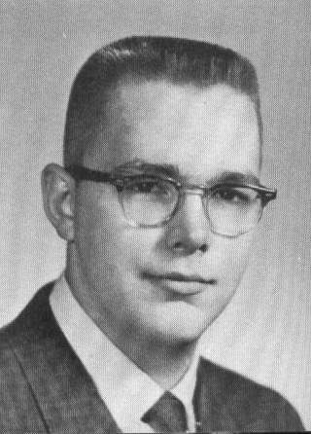
NAME: Stephen A MacKenzie

ADDRESS: 49 Stilliman Road
Wallington, CT 06492

E-MAIL: mackenziesannex@att.net

2012 COMMENTS:
After graduating from UNH in 1966 and having completed ROTC I started my stint with the
Army assiged to a Nike missle base. While
stationed there I met a young lady from
Scotland and after 4 months we were married.
I spent 1968 thru 1969 in Viet Nam and upon
my return I rejoined civilian life. I started work with H P Hood & Company
and was transferred to CT in 1971. I then joined Stop & Shop Co as a
distribution supervisor and during the next 33 years I held various
management positions and ended my career as the operations mgr of the
grocery distribution center. I retired in 2006.

My wife, Mhairi, and I are the proud parents of two lovely daughters and 3
grandchildren, the latest of which are two granddaughters born 6 months apart
in 2012. My grandson (1999) is more than delighted with his new sister.

* * * * * * * *
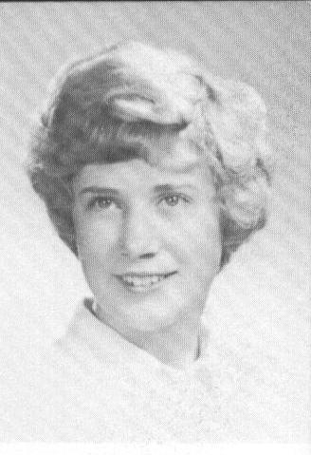

NAME: Janice (Magnuson) Cernoch

ADDRESS: 9 Hillcrest Drive
New Fairfield, CT 05812

PHONE: (203) 312-9376

E-MAIL: janicecernoch@gmail.com

* * * * * * * *

NAME: Dean T Mahan

SPOUSE: Linda (Audet)

ADDRESS: 2 Leanne Drive
Concord, NH 03301

PHONE: (603) 228-5517

E-MAIL: mlam1945@comcast.net

EMPLOYMENT: Evans Painting

CHILDREN:
Alan
Derek

GRANDCHILDREN:
Michael
Chrystal

* * * * * * * *
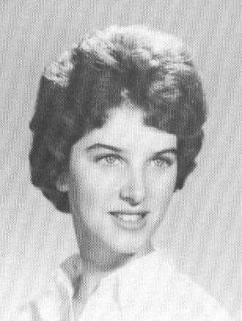
NAME: Theresa (Terry)
(Maheu) Dyke

SPOUSE: Thomas J Dyke

ADDRESS: 24 Mason Avenue
Pembroke, NH 03275

PHONE: (603) 485-7065
CELL: (603) 731-2042

E-MAIL: dyksta01@comcast.net

EMPLOYMENT: Self-retired

CHILDREN:
Bruce (1966)
John (1970)

2012 COMMENTS:
Have been married to Tom Dyke for 47 years. Bruce held executive positions
in the field of Information Technology and telecommunications and was
fortunate enough to retire two days before his 40th birthday. John graduated
cum laude from Dartmouth College and has been working for Federal Express
for the last 16 years.

I am currently semi-retired. Was a stay at home mom until boys reached school age and then in the 1970's worked as an Administrative Secretary at Concord Hospital. In the 1980's I worked ten years for a local bank as an Administrative Secretary. In the 90's I started my own business which continues to this date. I'm and animal advocate and love going to yard
sales and spending time at our cottage on Suncook Lake entertaining friends
and family.
* * * * * * * *

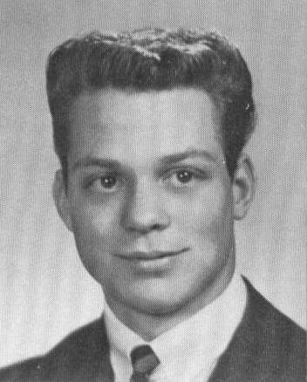

NAME: Michael C Malcolm

SPOUSE: Sisam (Shea)

ADDRESS: PMB180
PO Box 439030
San Ysidro, CA 92143

PHONE: (619) 704-8091 (Mexico)
CELL: (207) 415-1990

EMPLOYMENT: Retired

CHILDREN:
Debra
Jack

1992 COMMENTS:
It's good to be back in New England after so many years. I only wish the
winters weren't quite so long!

* * * * * * *
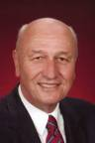
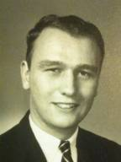

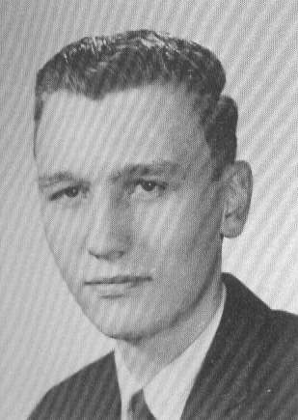
NAME: Richard T Martin

SPOUSE: Joan (Laplante)

ADDRESS: 65 Kensington Lane
Bedford, NH 03110

November - May
46 Redwing Court
Pawleys Island, SC 29585

PHONE: (603) 232-2261

E-MAIL: richard.martin3@comcast.net
rtm.3@me.com
joanmartin@comcast.net

EMPLOYMENT: Macy's - Bedford, NH
(Retired)
CHILDREN:
Robert
Michele

GRANDCHILDREN:
William

2012 Comments:
Having retired from a lifetime of retailing in 2005, we sold our larger house in Bedford in 2008 and bought a smaller house in Bedford and a winter home in Pawleys Island, South Carolina. Joan, a registered nurse,
worked at Mass General for 35 years on a cardiac unit, before retirement.

We now have six grandchildren, my son Robb has three boys and my daughter
Michele has a boy and two girls.

Life has been good to us and we thank God for his blessings.

* * * * * * * *
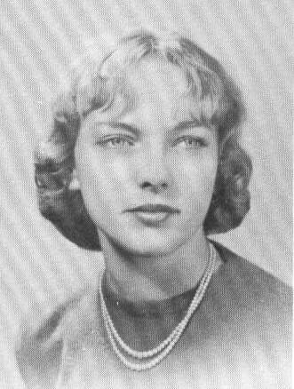

NAME: Elizabeth J (Mason)
Cote-Motes

ADDRESS: Prospect Street
Concord, NH 03301

PHONE: (603) 568-1078

E-MAIL: wesnjean@hotmail.com

CHILDREN: COMMENTS:
Martha Jean ------ (1963) - NHTI credit councilor
Priscilla Jean --- (1964) - Notra Dame / Manchester,NH - Para Legal
Donald Shawn ----- (1969) - Reiki Master & sales

GRANDCHILDREN:
David James ------ (1985) - Univ Co. Junior
Sarah Jean ------- (1987) - New England School of Culinary Arts, VT
Ryan Livingston –- (1991) - My artistic one
Spencer Armand --- (1995) - Merrimack Valley High School Senior, head math team
Charles Franacis – (2003) - Grade school, Portsmouth, NH

GREAT GRANDCHILD:
Zachery Mason ---- (2012)

2012 COMMENTS:
Greeting to my 1962 classmates. I hope life has been good to you & your
families.

I have been very blessed in my life in so many ways. In 1962 (September
after graduating I married) in 1963 had my first daughter Martha Jean ,
had my 2nd daughter Priscilla Jean, found out what caused them and took
a break until my son, Donald Shawn was born.

We have had a very interesting life between raising kids, starting foreign
repair garages, moving at NC, AL, FL then back to NH after my husband Donald
A Cote passed.

We lived on our sail boat "Camelot" in Ft. Lauderdale, FL where we bought
and ran a marine surveying business. It was really wonderful living on
“Camelot”, very peaceful and busy. Lots of family and friends staying on
board with us. Met some wonderful boating people.

Have 5 wonderful grandchildren and 1 great grandson. What JOY !!!

I went back to school to earn my degree in social work when Donald Shawn started school. Earned my BS from NH College then went on to the Master's program at Univ. of Conn. Worked for various agencies: National Alliance
for the Mentally Ill as an education advocate, Facilitator for Parents Anonymous weekly meetings, Manchester and Concord, Fulcrum Behavioral working with Court Adjudicated children, NH Hospital, adult population, CAP, working with elderly population, fuel programs, gob. food program, assisting other agencies or business in distributing Thanksgiving & Christmas food baskets and whatever other needs came about. On the Board of Directors for Parents Anonymous. I am a certified Educational Advocate for children with mental health issues, and certified guardian ad litem for NH.

Hobbies are: Grandchildren and Great Grandchild, genealogy (have my Mum's
side back to late 1700s) counted cross-stitch, reading, writing letters,
my gardens.

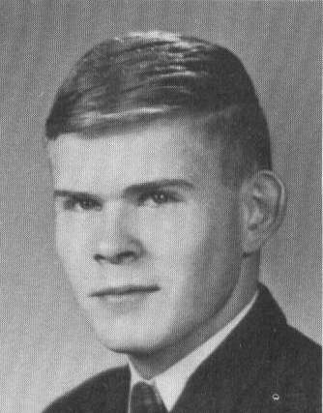
* * * * * * * *

NAME: Gordon D Matson

ADDRESS: PO Box 3955
District 5 Road
Concord, NH 03302-3955

E-MAIL: brassmag@comcast.net

* * * * * * * *
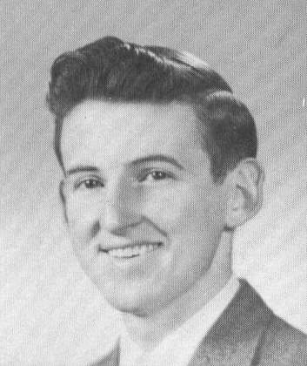

NAME: Harry K Mattice

ADDRESS: 48 Otley CT
Fort Myers, FL 33912-2125

* * * * * * * *

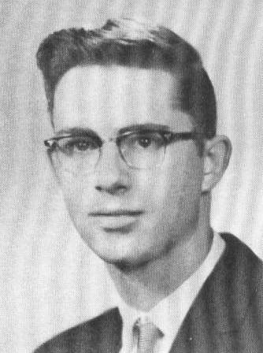

NAME: Lynn A Mayville

ADDRESS: 507 Old Wolfboro Road
Alton, NH 03809

PHONE: (603) 875-6282

* * * * * * * *
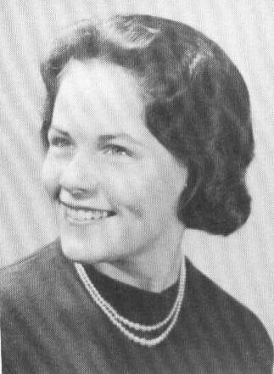

NAME: Bonnie A (McClintock) Nadin

ADDRESS: 8 High Street
Belmont, NH 03220-4516

PHONE: (603) 267-8143

* * * * * * * *
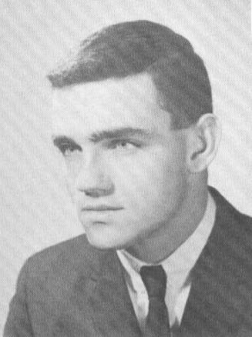

NAME: Stephen P McLoy

Deceased:
11/06/2006 – Myloid Leukemia

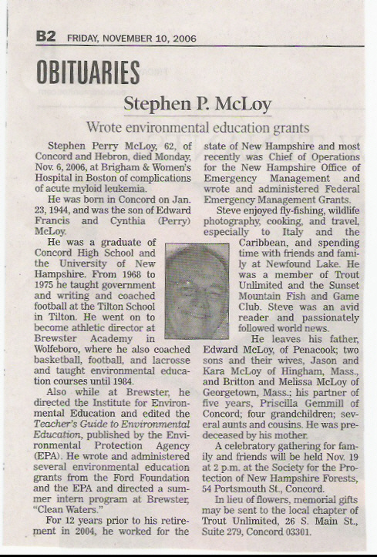

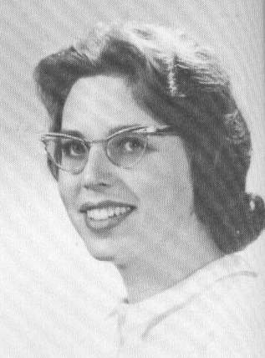
* * * * * * * *

NAME: Joanne M (Meissner)
Houston

SPOUSE: Donald B Houston

ADDRESS: 305 Maple Street
Contoocook, NH 03229

PHONE: (603) 746-3435

E-MAIL: djhouston@comcast.net

EMPLOYMENT: Programmer/Data Systems
(Part-time)
CHILDREN: COMMENTS:
Kimberly UNH '92
Wendy Hopkinton H.S. '93

* * * * * * * *

NAME: Maryann Meserve

ADDRESS: PO Box 2164
4313 Kenneth Ct
Titusville, FL 32780

PHONE: (321) 269-5282

EMPLOYMENT: Rocketdyne
(technical associate on Shuttle)

CHILDREN: COMMENTS:
Carole Resides in W. Virginia
Teresa Resides in Montana

1992 COMMENTS:
In 1982 my family and I were living in Tennessee. My husband was transferred
to Florida to work on the Space Shuttle program in 1983. There I taught
computer programming and word processing for four years, at which time my
husband was transferred again. From 1987 to 1990 we were in Mississippi –
boo! While there, I become seriously ill. Mississippi can do that to a
person! In 1990 we found outstanding medical care in Florida and we were
able to finagle a transfer back to the Sunshine State. I no longer work,
but I am enjoying life in spite of illness. Pat is still with the space
program, and our girls are grown and out on their own.

* * * * * * * *

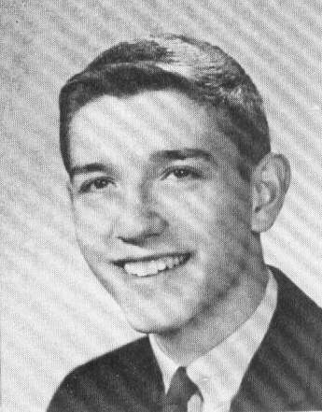
NAME: James W Milliken

SPOUSE: Susan (Violette)

ADDRESS: 33 Carter Street
Concord, NH 03301

PHONE: (603) 224-2664

E-MAIL: james.w.milliken@mwarep.org

EMPLOYMENT: Assistant General Manager-
Administration,
Merrimack County Te1ephone Company,
Contoocook, NH
CHILDREN:
James, Jr.
Andrew
Joshua

1992 COMMENTS:
Jim Jr. served in Desert Storm in the 1st Infantry Division (Tank Battalion).
Andrew is graduating from CHS '92 and going to Rensselaer Mechanical
Engineering. Joshua is going into 4th grade at Conant School. Susan is a
Certified Health Unit Coordinator and works as a Unit Secretary to Concord
Hospital in Maternity.

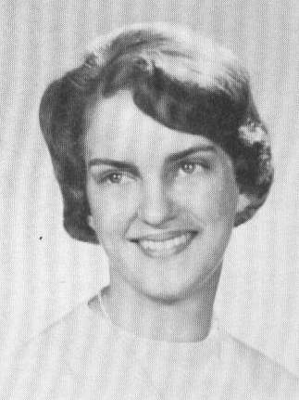
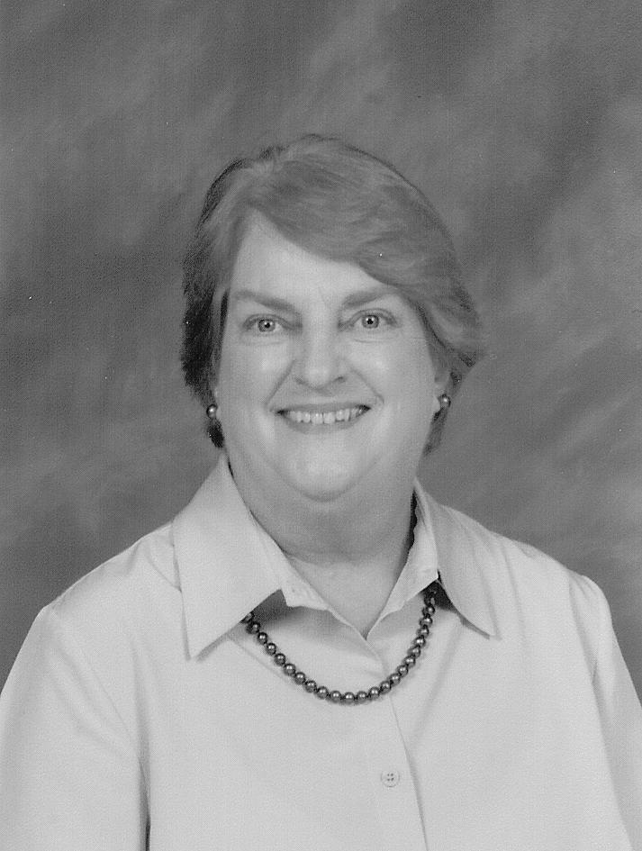
* * * * * * * *

NAME: Barbara (Mills) Lassonde

SPOUSE: Donald Lassonde

ADDRESS: 402 Route 103 East
Warner, NH 03278

PHONE: (603) 456-6052

E-MAIL: barbaralassonde@aol.com

EMPLOYMENT: Author, Poet & community volunteer

CHILDREN:
Kevin (1974)
Suzanne (1978)

2012 COMMENTS:
After graduating from business school, I spent 25 years helping my husband
operate a business while raising two kids. For the last 20 years, I've continued my education and have worked as a freelance writer, author & publicist, with no plans for retirement yet. I enjoy volunteering for charities, gardening, photography, making maple syrup, crafts, and most of all, playing with my young grandchildren.

I look forward to seeing everyone at the reunion!

2002 COMMENTS:
Married to Don for 35 years. Mother of two grown children, both living in
NH. One married, but I have no grandchildren yet.

I have authored / coauthored three books of New Hampshire history (and I
hated history class!), have written hundreds of articles for local, regional
and publications and have won numerous poetry awards. Twice nominated "Poet
of the Year", I was invited to read my work in Washington, DC and my poems
have been displayed in the NH State House.

I have been an active volunteer in the schools, church, scouting, 4-H and Red
Cross. I ran a church food pantry for eight years, served as president of
two women's clubs and currently chair the Concord Writers' Group, where I
mentor beginning writers.

My husband and I enjoy traveling, gardening and making maple syrup.

1992 COMMENTS:
For the last 22 years Don and I have owned and operated a booking agency for
entertainment. with an office in our home, I was able to work part-time and
stay home to raise our two adopted children. I also spent many years caring
for my parents in our home until their deaths.

I have spent the last three years focusing on developing my writing talent.
I returned to school night, took several writing courses, and am a 3 year
member of the Concord Writers' Group. I have had several poems published
and recently received awards for two. One placed in the top 1% of some
10,000 entries in an international competition, and another took first place
in a state-wide competition. With that boost of encouragement, I am giving
up my part-time jobs to become a full-time writer. I have several short
stories and some children's books I am trying to get published, and am
currently working on a how-to book and novel for teenagers.

I still enjoy doing charity work. I am past president and 8 year member of
the Junior Women's Club and am now vice president and a 3 year member of
another women's club. I do a great deal of charity work through the club,
I work for the Red Cross every month, and teach Sunday school every week.
I was a Brownie Leader for 3 years, and have volunteered with the 4-H, Boy
Scouts, schools, and tutored through the Adult Tutorial Program.

I enjoy spending time at our cottage at the lake in the summer. Our son will
be a senior at CHS this fall and our daughter a freshman at Rundlett. Don
and I will be celebrating our 25th anniversary in October.

* * * * * * * *

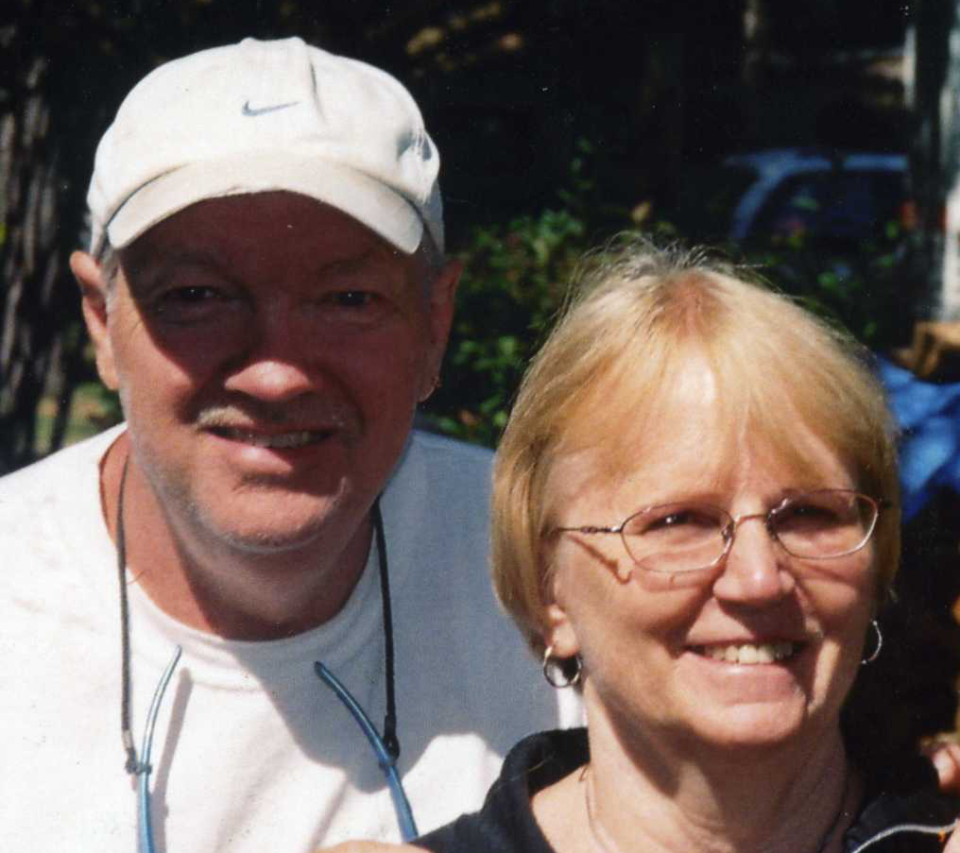
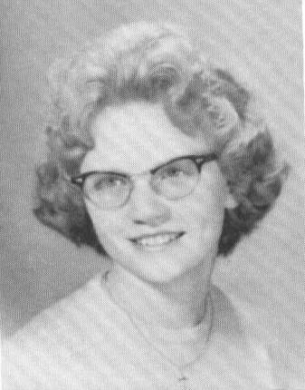

NAME: Linda L (Moore) Clark

ADDRESS: 6 Indian Point Road
Loudon, NH 03307

PHONE: (603) 798-5992

E-MAIL: lin.clark@comcast.net

EMPLOYMENT: St. Paul's School, Concord, NH (Retired)

2012 COMMENTS:
Not a lot has changed – only our ages. My husband & I still live in Loudon, NH for 29 years in June.

We still love the country – have a vegtable garden & plunty of flowers to care for.

I retired from St. Pauls School in 2008 after 27 years of service. I worked
in many of the buildings on campus & the Rectory where Special events took place. Saturday nights, was open house for students.

We both love animals & have 3 cats. My husband chose the beauty salon business, owning & operating Clark’s Beauty Salon for over 20 years. His clientele included many of Concord’s residents. In 2003,he started Inland Prints which includes all occasion note Cards – other interests includes photography & gardening.

2002 COMMENTS:
My husband and I have lived in Loudon, NH for 19 years. We love the country.
We love gardening, camping and enjoy our four cats. My husband, Richard, is
an artist. I have worked at St. Paul's School for 21 years and am looking
forward to retiring in a few years.

* * * * * * * *
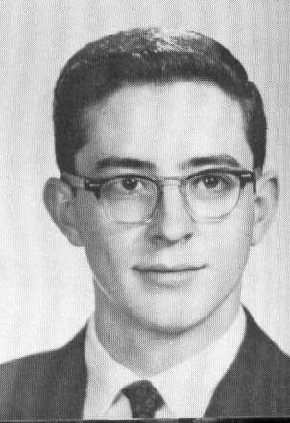
NAME: David A Morin

SPOUSE: Constance J

ADDRESS: 60 Plummer Road
Bedford, NH 03102

PHONE: (603) 669-8453

E-MAIL: dmorin1@comcast.net

EMPLOYMENT: Retired

* * * * * * * *
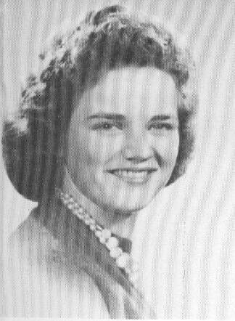

NAME: Carol J (Morrill) Audet

ADDRESS: 508 Clinton Street
Bow, NH 03304

PHONE: (603) 224-2262

E-MAIL: nbow@comcast.net

2012 COMMENTS:
After graduation, I Married Peter Audet and raised two children. Worked at
Concord Hospital Medical Laboratory as a Laboratory Assistant and retired
after 40 years of service. I loved my work at the Laboratory and I so miss
the patients and my coworkers. Still enjoying my home in Bow and have been
here 45 years. Maintaining my home keeps me very busy.

My daughter Susan is a local businesswoman and also a pilot. My son, Peter, is a local businessman. He and his wife enjoy traveling, including Alaska each summer.

Both my Daughter and Son have homes here in Bow.

Looking forward to our 50th reunion. See you there!

* * * * * * *
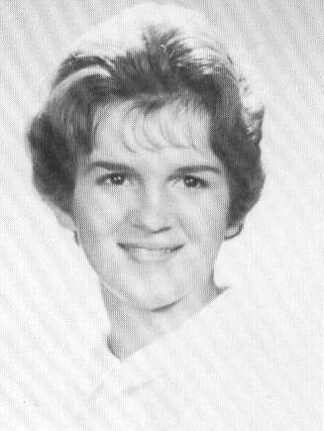

NAME: Despina S (Moskos) Attalla

ADDRESS: 110 Coliseum Drive #203
Nashua, NH 03063

PHONE: (603) 595-7416

E-MAIL: despinamoskos@comcast.net

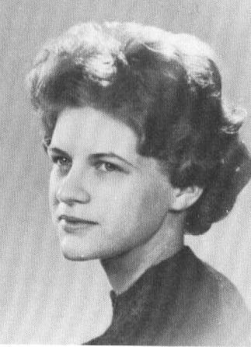
* * * * * * * *

NAME: Nina L (Moulton) Pneuman

ADDRESS: 101 North Maple Street
Wilmore, KY 40390-1140

PHONE: (859) 858-9067

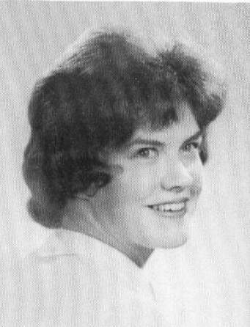
* * * * * * * *

NAME: Sharon (Moynihan) Roy

SPOUSE: Ronald H Roy

ADDRESS: 715 Harbor Drive South
Venice, FL 34285-3113

PHONE: (941) 485-5756

E-MAIL: ronhroy@aol.com

CHILDREN:
Lisa
Michelle

2012 COMMENTS:
Just wanted to inform you that I will not be attending the reunion. I am in
the process of moving back north to PA.

I wish the CLASSMATES of CONCORD HIGH class of 1962 well. I can't believe it
has been so long. I am sure it will be a wonderful time and lots of fun and
OLD memories in the conversations.

Thank you for the committee’s effort that have put into this project.

1992 COMMENTS:
I'm certainly looking forward to seeing my classmates. We moved to PA in
1975 and therefore don't have a chance to see or keep in touch with any of
the Class of "62. The class reunions are really great fun for us, they give
us a chance to touch base with old friends.

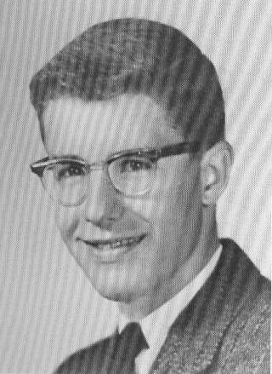
* * * * * * * *

NAME: Edward J Mulligan, Jr.

Deceased:
xx/xx/1969 - Cancer

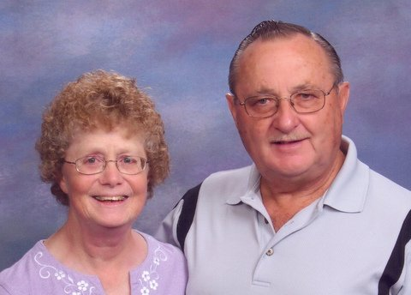
* * * * * * * *

NAME: Sharon L (Munsey) Pray

SPOUSE: Charles E Pray (1966)

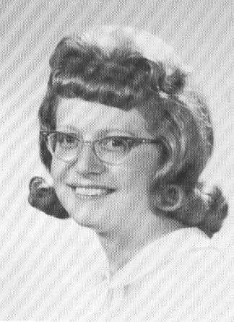
ADDRESS: 5566 Ontario Center Road
Ontario, NY 14519-8645

PHONE: Home (315) 524-2028

E-MAIL: theprays@rochester.rr.com

EMPLOYMENT: Rite-Aid
10 years as a Pharmacy Clerk

Wayne Central School District
20 years as teacher aide (Retired)

CHILDREN:
Vicki (1968)
Matthew (1970)
Eric (1973)

GRANDCHILDREN:
Courtney (1990) Theresa (1991)
Chelsea (1991) Nicholas (1993)
Nicole (1994) Amanda (1995)
Hannah (1997) Emma (2005) Seth (2006) Jack (2008)
Kaden (2009)

2012 COMMENTS:
MY LIFE SINCE JUNE, 1992
Married in 1966 to Charles E. Pray, who graduated from Penacook High School
in 1958. We have 3 children, 10 grandchildren and one great-grandchild.

I have worked at Britts Department Store (Head Cashier); United Life (Policy
writer); Sears (Account clerk); Wayne Central School District (Teaching Assistant); and Eckerd Drugs (Pharmacy Tech), and did some income tax returns for 30 years.

Chuck and I have traveled to: Hawaii, Australia, New Zealand, Tahiti,
Puerto Rico, Spain, Canary Islands, Morocco, Mexico, Bahamas and Belize.

Hobbies and Activities include: Girl Scouts, Boy Scouts, PTA, Bowling,
Camping, Walking, Card-making, Auto racing and volunteering.

2007 COMMENTS:
Me - retired
Husband, Chuck - retired

Biggest news:
Chuck and I just came back from 22 days "down under" in Australia, New
Zealand and Tahiti !!!!

2002 COMMENTS:
Hobbies: Stock car racing, card-making, camping, neopets.

* * * * * * * *
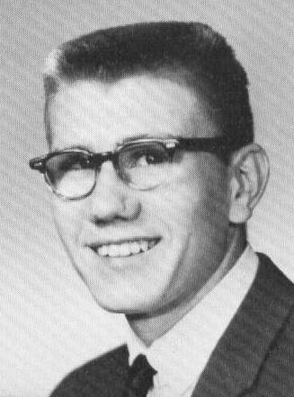

NAME: William J Murdoch

ADDRESS: 49 Lake Street
Concord, NH 03301

PHONE: (603) 225-5770

* * * * * * * *

NAME: Miriam L (Murray) Cerone

SPOUSE: Hugh Best

ADDRESS: 20609 Larino Loop
Estero, FL 33928

PHONE: (239) 495-7738

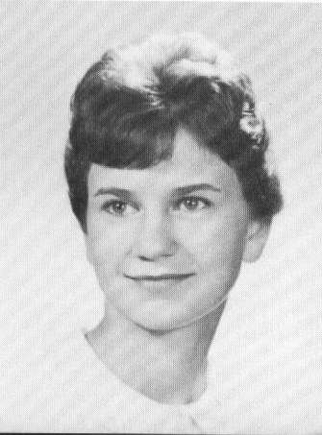
E-MAIL: mlcer@yahoo.com

EMPLOYMENT: U Conn Health Center (retired)

CHILDREN:
Seth (1979)

2012 COMMENTS:
I spent my first winter in FL in 2002 and decided I wasn't going to endure any more winters up North. I met my husband, Hugh
in 2005 and we decided to sell our homes up North and live permanently in FL. We love the FL lifestyle of fun and play and are fortunate to have the good health to enjoy this life.
I have traveled quite a bit in and out of the US and have lived in NY, NC and CA.

I still go up to Murray Farm Greenhouse every Nov-Dec to help out and decorate xmas wreaths, so please ask for me if you come in or say “hi”
if you see me, as I might not recognize you. This seems to get harder
every year we get older.

2002 COMMENTS:
After 37 years of working in Nuclear Medicine. I've returned home to care
for my parents and work part-time in the greenhouse at Murray Farms.

I hope to see many classmates in the future and hope you will inquire for
me if I don't happen to be in the greenhouse at the time of your visit.

1992 COMMENTS:
I have finally settled in Connecticut after living in many parts of the U.S.
It is nice to be back near family and friends. I am working in nuclear
medicine at the University of Connecticut Health Center which is a teaching
and research facility. We are also the regional neonatal care center and
the Children's Cancer Research Center. I have missed our last two reunions
so I am looking forward to our 30th.

* * * * * * * *
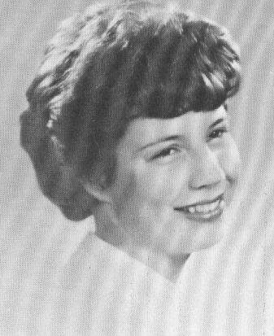
NAME: Patricia A (Murray) Lee

SPOUSE: Richard "Dick" Lee

ADDRESS: 601 Newark Street
West Burke, VT 05871-9717

PHONE: (802) 467-1300

E-MAIL: pal_ral@msn.com

EMPLOYMENT: RN, Northeastern VT Regional Hospital
Emergency Department

2012 COMMENTS:
Where have 50 years gone? Jeeze Louise... I have two living sons that have
turned out to be awesome, super intelligent human beings; Sean, age 46, and
Patrick age 41, What more can I ask for!

Have been married 47 years, to a man I loathed at first sight! He is now my
soul mate.

I have come full circle now, from the farm life in Loudon to a farm in VT,
with Shetland sheep, chickens, and vegetable gardens. We did reverse
retirement, not planning for old age, but enjoyed traveling the West in a
pickup truck, backpacking, mountain biking, fishing etc...did not want to
end up like many wishing they had done something fun. Went to Alaska..
should have stayed!

I am planning on coming to the Saturday soiree...

* * * * * * * *
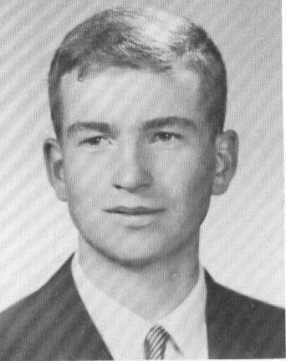

NAME: Bruce S Nelson

SPOUSE: Christine (Economos)

ADDRESS: 3 Samantha's Way
Wilton, NH 03086

PHONE: (603) 654-6594
CELL: (603) 315-7052

EMPLOYMENT: Guilford Rail, N. Billerica, MA

CHILDREN:
Lauren (1983)
Arron (1988)

2012 COMMENTS:
I graduated from UNH '67 and was in ROTC. Spent 2 yrs active duty in field
artillery stationed in Germany. Started working for the railroad in 1962
summers and school vacations while at UNH. After the Army I went to work
for Penn Central in management. After 4 yrs went to the Boston and Maine
Railroad in Management located in Boston, MA, Mechanicville, NY and North
Billerica, MA until I retired in 2004. Chris and I lived in North
Bennington, VT for 10 yrs and have know been in Wilton for 27 yrs and don't
plan on going anywhere soon.

My hobbies over the years have been woodworking, photography, wine, gardening, carpentry, and cycling. Our daughter Lauren went to High Mowing School, Eastman School of Music (BA), Univ of Kentucky (MA), and is currently enrolled in an advanced degree viola performance program at New England Conservatory. Aaron graduated in December from UNH with a degree in psychology and is working as a councilor and is looking toward grad school. Both Lauren and Aaron are Korean and were adopted when infants. We are very proud parents!

* * * * * * * *
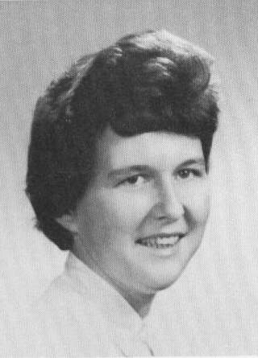

NAME: Sharon E (Nylen) Atwood

ADDRESS: PO Box 5
34 School Street
Cornish Flat, NH 03746

PHONE: (603) 543-3836

* * * * * * * *
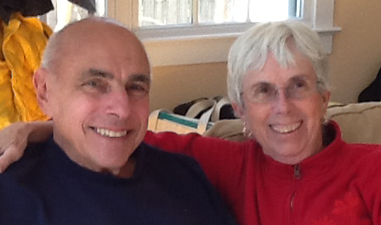

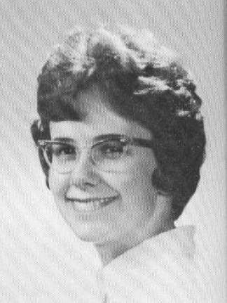

NAME: Claire (Osborne) Sklarin

SPOUSE: Michael Sklarin

ADDRESS: 469 Suncook Valley Hwy
PO Box 7
Epsom, NH 03234

PHONE: (603) 736-9360

E-MAIL: Claires@metrocast.net

EMPLOYMENT: Dr. A.R. Binder,
Dental Hygienist (Retired)
CHILDREN: COMMENTS:
Christopher (1965) - Wife, Alexis, daughter Maya, son Wyatt
Hilary (1968) - Husband, Eric, daughter Madeline
Andrew (1974) - Wife, Tracy

GRANDCHILDREN:
Madeline (1995)
Maya (2002)
Wyatt (2004)

2012 COMMENTS:
After CHS I attended Westbrook College. I majored in dental hygiene. I
married Mike in Sept. ’64. We moved to Pensacola, Florida. Mike was an
officer in the Navy. We moved to the west coast with our 1st. son. Mike
deployed to the Philippines. Our 2nd child was born in Cavite City in 1968.

Around 1970 Mike got out of the Navy and we bought our house here in Epson,
NH where we still live today. Our 3rd child was NH born in 1974.

I worked part time many years in Concord as a dental hygienist. I retired in
1995 and spend most of my time sewing and doing machine embroidery.

Mike and I have host many foreign exchange students. We have enjoyed over the
years having return visits from them and our own visits to their homes.

2002 COMMENTS:
Mike and I are still in Epsom. I've been retired now for 7 years.
(No more tooth stories) I am very busy with sewing machine embroidery.

We travel whenever we can. Most resently to CA to our son and
daughter-in-law's graduations from Berkeley. Chris got his MBA and
Alexis her PHD in Mechanical Engineering. We also got to see and spoil
our latest granddaughter, Maya, who was born in 2002.

Hilary works with Mike here in Epsom and from her home in Dunbarton.
Her daughter, Madeline, is in second grade. Madeline is almost as
big as I am. Right now, we wear the same size shoe. She keeps me
on my toes as she reads at 5th grade level.

Andy, our youngest, also works in the insurance agency. He plays
lots of tennis, guiter and french horn. Andy lives in Derry and
spends lots of time with friends in the Boston area.

Some of the other places we have visited in the last ten years are
Paris, New Zealand, Austria, Denmark, Sweden, Germany and Aruba.

It is really great to be retired and sort of foot loose and fancy
free.

1992 COMMENTS:
Looking at the ages of my children I know it has been 30 years since CHS,
but it doesn't seem that long. I'm still cleaning teeth 3 days a week.
We've had a busy '92. Our daughter, Hilary, was married on May 2nd in
Dunbarton, NH. Our son, Andy, graduated in June from Derryfield in
Manchester, NH. He is going to Oberlin College in September. Our oldest,
Chris, and his wife, Beth, live and work in nearby Massachusetts. They
have a pet Sheltie. So we're grandparents to a dog. Mike is busy with
his insurance agency and hardball. I still find time for sewing and crafts.

* * * * * * * *

NAME: Damon Osgood

ADDRESS: 86 Mountain Road
Concord, NH 03301

PHONES: (603) 228-3722
(603) 224-1537

* * * * * * * *
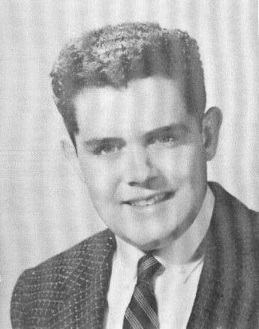
NAME: Lawrence W Otis

Deceased:
08/15/2012 - COPD

SPOUSE: Joanna (Houston) Otis

ADDRESS: 30 Branch Turnpike Road
Concord, NH 03301-5719

PHONE: (603) 225-2319

E-MAIL: jotis@comcast.net

EMPLOYMENT: Secure Care Products, Inc.,
Concord, NH
CHILDREN: COMMENTS:
Michael - PMP IT Project Manager, MKS Instruments – Andover, MA

2012 COMMENTS:
To my classmates of CHS '62

I am sorry I will not be able to join all of you at the Reunion.

I am now retired and on oxygen 24/7; get around very slowly with a walker
and seldom get out of the house.

Hope you all enjoy the Reunion!

===================================================================

Obituary:

Lawrence "Larry" W. Otis, 68, passed away Wednesday, August 15, 2012 at
Pleasant View Nursing Center in Concord.

Born in Concord, he was the son of Harold and Bernice (Townes) Otis and
was a lifelong resident of Concord. Larry very seldom forgot the names
and faces of people he met, and within minutes of meeting somebody he
would learn something about that person and remember it in their next
conversation.

He had small town values about life and work that helped his career
progress from a part-time yardman at Northeast Electronics while he was
still in high school through working his way up to become the Inventory
Control Manager at Northern Telecom 28 years later. Larry was featured
on the cover of Northern Telecom's newsletter in May 1988 as the
corporation's employee of the month.

He came up through the ranks, but never forgot what it was like to do
those other jobs. In addition, he worked in the Census Office during
the 1990 census and finished his career by working as a Supervisor at
Secure Care Products for 15 years.

On November 28, 1964 he married his wife Joanna (Houston) Otis. In 1989
they celebrated their 25th anniversary in Hawaii.

Larry volunteered with the Boy Scouts of America and the Capital Region
Christmas Food Basket Program for several years. He loved to work, but
also enjoyed camping with his family and fishing with his uncle when he
was a youth. He and his wife were members of Concord Coach Square Dance
Club for several years and thoroughly enjoyed square dancing.

Survivors include his wife Joanna Otis of Concord; his son Michael Otis
and his wife Pamela of Derry; his sister Sandra Landry; four nephews and
one niece.

Calling hours will not be held.

Graveside services will be held Monday, August 20, at 2 p.m. at Blossom
Hill Cemetery in Concord.

In lieu of flowers, memorial contributions may be made to the charity of
one's choice or to Granite United Way, Merrimack County Region, 46 South
Main Street, Concord, NH 03301.

The Bennett Funeral Home of Concord is in charge of the arrangements.

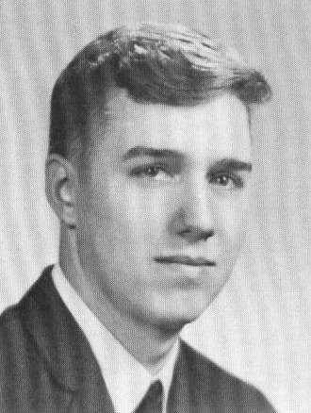
* * * * * * * *

NAME: Clark D Page

SPOUSE: Patricia J (Moore)

ADDRESS: 707 Loudon Ridge Road
Loudon, NH 03307-1711

PHONE: (603) 776-7761

EMPLOYMENT: Self-Employed,
C P Welding & Boring

CHILDREN:
Rebecca
Clark

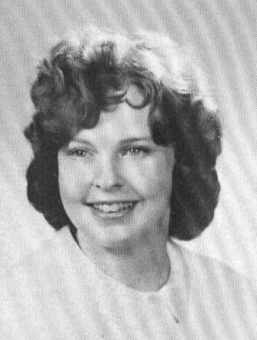
* * * * * * * *

NAME: Sharon L (Paige) Hodgdon

SPOUSE: John Hodgdon

ADDRESS: 134 Mariner Lane
Rotunda West, FL 33947

PHONE: (941) 697-7336

SUMMER: York Beach, ME 03910

PHONE: (207) 363-4922

E-MAIL: jshodgdon@comcast.net

EMPLOYMENT: Retired from NYNEX in 1994

CHILDREN: COMMENTS:
Shawn Works for Brook Farm Distributors
Dawn 1991 Graduate of NHTI

GRANDCHILDREN:
Lelia
Sadie

2012 COMMENTS:
Worked for Verizon 32 years. Retired to Florida in 2001. Two Children, four
grandchildren. Spend summers at York Beach, ME! Enjoy the beaches, boating,
singing with the Tonettes, volunteering and Rotonda West Woman’s Club.

2002 COMMENTS:
We moved to FL in June 2001. We are enjoying "our little slice of paradise"
near the Gulf of Mexico in southwest FL. Lots of boating & golf to keep us
busy!

We have been staying at our cottage in York, ME for the summer and, due to
previous commitments, we must return to FL by mid September. Sorry to miss
our 40th reunion. Best wishes to everyone.

1992 COMMENTS:
Looking forward to seeing everyone again! Five years passes so fast.
Thirty years doesn't seem possible! I don't remember getting older!
Hoping to retire after 30 years with New England Telephone Company.
Both children are on their own and doing well, now it's my turn! See
you on the 18th!

* * * * * * * *
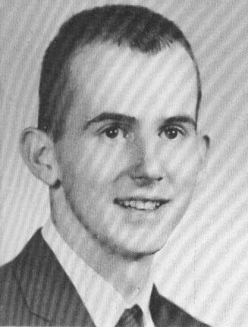

NAME: Jeffrey E Parmenter

ADDRESS: 43 Fisherville Road
Concord, NH 03301

* * * * * * * *
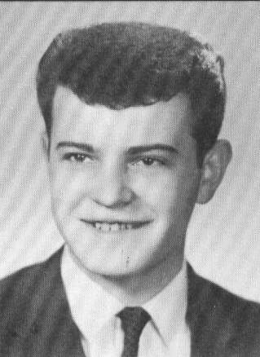

NAME: Michael M Paveglio

Deceased:
04/12/2010 – xxxxxxxxxx

===================================================================

Obituary:
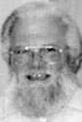
Michael M. Paveglio, 65, of Curtis Avenue
in Concord, died Monday, April 12, 2010,
at the VA Medical Center in Manchester.

He was born in Concord, the son of the late
Matthew Paveglio and Sarah A. (Murphy) Paveglio
of Concord.

He was a graduate of Concord High School, Class
of 1962.

He was a veteran of the U.S. Army, serving during
Vietnam.

He worked as a plumber for the state of NH for
many years. Before his retirement, he worked at
the Steeplegate Mall in Concord.

He loved to hunt and fish. Michael had a great sense of humor and was a
great storyteller. He was a dog lover and his two favorite dogs, Waylon
and Zack, predeceased him.

In addition to his mother, he is survived by his son, Anthony V.
Paveglio and his fiancee, Amanda Mullen, of Salisbury; his sister,
Ann Daley of Manchester; and nieces, nephews and cousins.

Memorial visiting hours will be held tomorrow from 6 to 9 p.m.
at Waters Funeral Home, 50 S. Main St., Concord.

Graveside services will be held Friday at 11:30 a.m. at the NH State
Veterans Cemetery in Boscawen.

* * * * * * * *

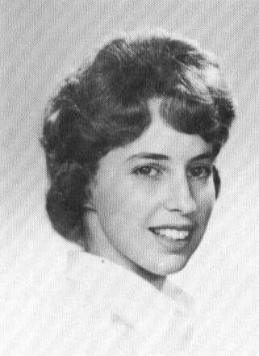
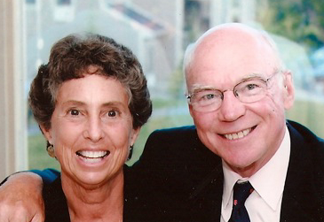
NAME: Anne P (Pelren) Drinon

SPOUSE: See Joseph M Drinon

ADDRESS: 42 West Road
Chichester, NH 03258

PHONE: (603) 798-5163
CELL: (603) 496-3437

E-MAIL: ADrinon@comcast.net

EMPLOYMENT: Woodside School (Retired teacher)

CHILDREN:
Garrett (1982)

2012 COMMENTS:
Before retirement, I sold real estate on the coast of NH and then taught
kindergarten for many years in Concord. I have been involved with the
YMCA as a volunteer as well as a member for over 20 years.

I have always loved working in my gardens, am an avid reader and continue
to enjoy a very active life style. I began playing golf 4 years ago and
that is an experience in itself.

Joe and I are enjoying retirement. We have done some traveling to Arizona,
California and Florida to visit with relatives. We have also spent time in
New York City to see our son, Garrett, perform who is a musician and lives
in Brooklyn. We both enjoy playing golf and snowshoeing. We still own our
1838 farm house in Chichester with many perennial gardens, a wonderful view
and continue to enjoy country living.

2002 COMMENTS:
As your grandchildren are growing up and your youngest kids are getting
married, Joe and I are now just beginning the "empty nest' syndrome.

Garrett graduated from St. Paul's School in June and will head to the
University of Pennsylvania in the fall. He will row for the Quakers and
is thrilled about living in Philadelphia.

Joe has been working for UBS Paine Webber for 30 years now. He and his
partner, Brad Thomas (class of 1960), have tried to keep smiling during
this simply terrible Bear market.

Joe's passion is still basketball and he has coached at the Concord Boys
and Girls Club as well as at the AAU level for the past 10 years.

I was a real estate broker and teacher until I retired four years ago.
We have an old farmhouse in Chichester of which I love working in our
perennial gardens. I also love reading, working out and having time for
close friends.

1992 COMMENTS:
While most of you are going through the "empty next" syndrome, becoming
grandparents or at least sending a youngster off to college, Joe and I
are trying to keep up with an active 9 year old boy! We find ourselves
trying to see which one of us can get Garrett to baseball or some other
sport. I am a kindergarten teacher in Concord at Woodside School and
enjoy this profession very much. Joe is still a stock broker with Paine
Webber in Concord and has seen quite a change in the profession in the
past few years. We live in Chichester and have enjoyed this small
community for the past 12 years. We have an old cape with a barn...
built in the early 1800's...and we have loved this place since the first
time we saw it.

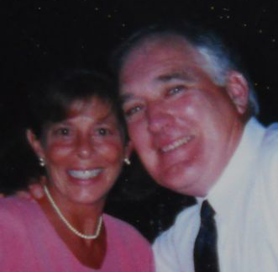
* * * * * * * *

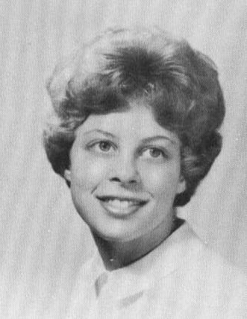
NAME: Margaret P (Pelren)
Brewitt

SPOUSE: Peter Brewitt

ADDRESS: 161 Whitten Road
Kennebunk, ME 04043

PHONE: (207) 985-7262

E-MAIL: pbrewitt@roadrunner.com

EMPLOYMENT: Meadow Weeds Farm
Dried floral design

CHILDREN: COMMENTS:
Matthew (1970) - Wife, Kara
GRANDCHILDREN:
Matthew "Jake" Jr. (2001)
Brooke (2004)

Stephen (1971) - Wife, Melissa
GRANDCHILDREN:
Colin (2004)
Riley (2005)

PETER'S CHILDREN
Shaun (1966)
GRANDCHILDREN
Riley (2003)

Darcy (1969)
GRANDCHILDREN
Taylor (1988)
Jordan (1997)

Dain (1971)
GRANDCHILDREN
Shane (1997)

2012 COMMENTS:
Peter and I will be retiring as of May 2012. We have lots of “happy
plans”, and after 25 years of marriage hope to spend more time with our
gang of 8 combined grandchildren. More time at the Brewitt Cottage on
Lake Winnipesaukee is definitely on the agenda.

We have a farm in Kennebunk, Maine, and love to spend time in our large
vegetable garden, 26 flower beds and harvesting fuel wood from the wood
lot for the winter woodstove. We maintain a little roadside stand for
our blueberries and vegetables.

Peter has a woodworking shop and sells many of his crafts on-line and at
craft-shows, and I have a dried floral studio where I enjoy creating floral
and seashell designs for many local clients and shops.

I look forward to our 50th and seeing old friends and sharing memories.

2002 COMMENTS:
Peter and I have been married for 15 wonderful & "adventuresome" years.
We have five children between us. I have two sons from my first marriage
(Stephen P McLoy: class of 1962). They are married (I am blassed to have
the greatest daughters-in-law) and work in Boston.

Jason & Kara blessed me with my first grandbaby, Jake on June 5, 2001.
He is the love of my life. Jason & Kara live on Brimmer Street in Boston.
Jason works in the investment firm of CIBC Oppenheimer. Kara is a lawyer
with Holland & Knight.

Britt & Missy are restoring an old house in Georgetown, MA. They spent
their first tear of marriage in New Haven, CT. Thanks to Missy's
devotion.... Britt earned his MBA from Yale and is a financial analyst
for Newberger, Berman. Missy works for Fleet Bank.

I retired from 30 years in dental hygiene. Peter and I bought & restored
our farm in Kennebunk, ME four years ago. I have my own business at home
and with Peter's devotion and "Green Thumb" are growing & preserving flowers
for floral design.

* * * * * * * *
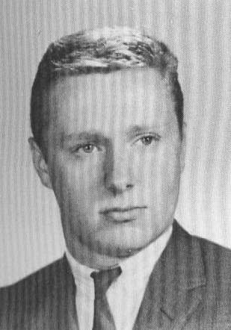

NAME: David A Penhale

ADDRESS: PO Box 5433
Snowmass Village, CO 81115

CELL: (970) 309-4502

E-MAIL: penhallow@gmail.com

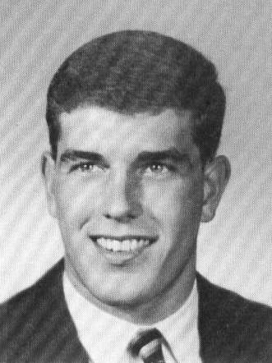
* * * * * * * *

NAME: Arthur W Perkins

SPOUSE: Cheryl A (Swanson)

ADDRESS: 87 North State Street
Concord, NH 03301

PHONE: (603) 224-3323

E-MAIL: arthur@awperkinslaw.com

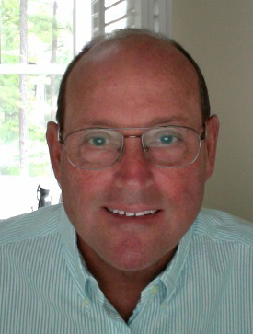
* * * * * * * *

NAME: William D Perkins

SPOUSE: Jane M

ADDRESS: PO Box 607
109 River Street
Wolfeboro Falls, NH 03896

PHONE: (603) 569-5156

E-MAIL: Perkins1717@gmail.com

EMPLOYMENT: President of 3M Dynacolor
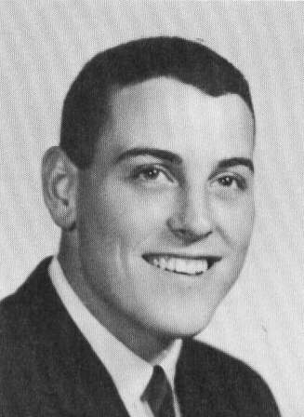
Corperation CEO and Managing
Director of 3M's SEA Region
(South East Asia) and 3M's
European Benelux Region
(Belgium, Netherlands, Luxemburg)
(Retired)

CHILDREN:
Kelly (1969)
Samantha (1995)
Alexander IV (1996)
Maxwell (2005)

Meredith (1973)
Sage (2007)
Quinn (2009)

Bailey (1978)
James (2004)
Cade (2007)
Brady (2008)

2012 COMMENTS:
My wife Jane and I have been happily married for 46 years. Our 3 daughters
all married terrific young men. Together, they have given us 8 beautiful
grandchildren.

I was employed by 3M for 31 years and retired in 2004.

We were very blessed to be able to experience living in Singapore for 5 years
and Brussels, Belgium for 7 years. That opportunity enabled us to travel to
most countries in Asia, Europe, South America, Eastern Europe, Africa and
Middle East.

Today I still enjoy traveling, along with fishing, boating, snorkeling and
walking our two dogs.

Recently I was chosen to be Vice Chairman of the Board of YMCA Camp Belknap,
a boys summer camp on Lake Winnipesaukee, where I spent 14 years as a camper,
leader and division head.

I wish you all great happiness and hope all your aches and pains are little
ones.

2002 COMMENTS:
Jane and I happily celebrated our 36th Wedding Anniversary in June and I have
now been with 3M for 30 years.

After living happily in Belgium for the past five years, we are now
finalizing our plans for our new home, to be built in Wolfeboro, NH,
beginning next summer.

We have loved living in Europe and have very fortunate to have been able to
visit most all of the countries.

Currently, I am responsible for 3M's business in Belgium including, 3M
Europe. I have enjoyed the challenges of running 45 Divisions and a major
chemical manufacturing operation in Antwerp. The Belgian 3M people have
been great employees and friends.

We plan to retire within the next two years and look forward to our years
ahead in NH (no better place in the world) and FL in the winter.

Sorry to have missed the reunion ... We will see you at our 50th for sure.

1992 COMMENTS:
Jane and I happily celebrated our 26th Wedding Anniversary in June and I have
now been with 3M for 20 years.

We have loved living in Singapore for the past four years. The Singaporeans
are wonderful, bright, fun loving and very hardworking, and the country is safe, clean and beautiful. Visiting many Asian countries had been a great
experience for our whole family.

Currently, I am Managing Director of 3M Singapore, 3M Malaysia and 3M
Indonesia. We employ over 600 local employees whose careers range from
sales, marketing, R&D, manufacturing, IS&DP, warehousing, finance and
administration. We sell over 6000 3M products into 23 different markets
in 10 countries. A challenging yet very rewarding experience.

Jane seems to grow more beautiful with the years while I am noticing a few
grey flecks on my already thinning top. Other than that, we've not changed
much. Sorry to miss you. Hopefully, we'll be in the States for our next
reunion.

All the Best!

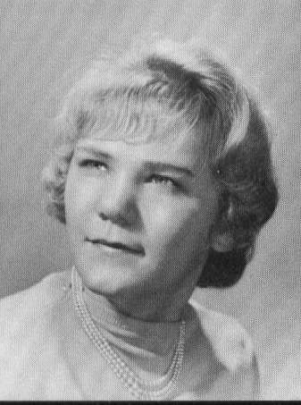
* * * * * * * *

NAME: Brenda J (Perron)
Plummer

Deceased:
10/xx/2006 – Breast Cancer

SPOUSE: Carl Plummer (40 years)

ADDRESS: 92 King Road
Chichester, NH 03258

E-MAIL: pugkia@tds.net

EMPLOYMENT: Concord High School

* * * * * * * *
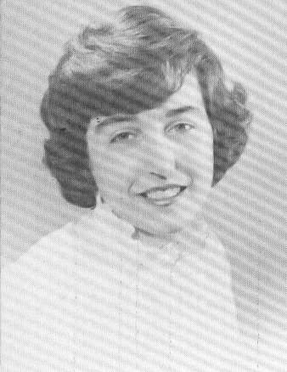

NAME: Joan F (Perry) Miller

SPOUSE: Ed Miller

ADDRESS: 408 Sawgrass Cove
Sneads Ferry, NC 28460-9115

PHONE: (910) 327-2988

E-MAIL: sawgrasscove408@gmail.com

* * * * * * * *
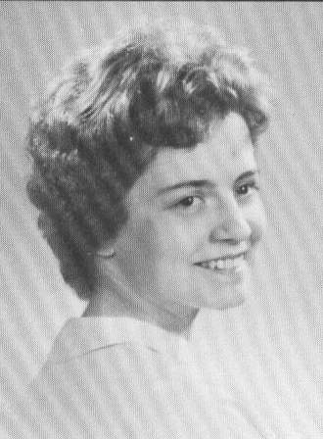

NAME: Jo-Ann Peterson

ADDRESS: 101 New England Road
Guilford, CT 06437

PHONE: (203) 453-6228

E-MAIL: jpetersonct@Hotmail.com

EMPLOYMENT: Picture Framer

CHILDREN:
Kimberly
Kevin
Christopher

* * * * * * * *
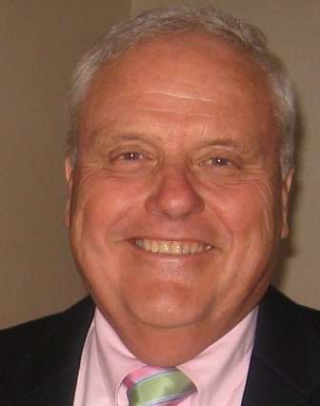
NAME: Roger B Phillips

SPOUSE: Susan C

ADDRESS: 8 Pine Street
Concord, NH 03301

PHONE: (603) 225-3660

E-MAIL: rbpplo@aol.com
roger@phillipslawoffice.com

EMPLOYMENT: Phillips Law Office, P.L.L.C.
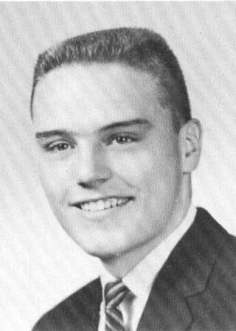

CHILDREN:
Kristin
Lori
Justin

2012 COMMENTS:
The most significant change since our 40th reunion is that Sue and I are now grandparents of five grandchildren and two step grandchildren. Craig is entering his sophomore year at UNH, Daryn is a sophomore at Londonderry High School, Jack is entering the 4th grade at the Abbott Downing School (the new school at the site of the former Conant School), Grace is a first grader at
Abbott Downing, and Samuel Roger is in pre-kindergarten. Parker completed
his first two grades at the Walker School and he and his sister, Lily (a
second grader), will now be going to the Christa McAuliffe School (on the
site of the former Kimball School).

Wife, Susan, is still active as the part owner of Caring Gifts in Concord and
I am still practicing law, although my emphasis in trial practice is in the
consumer law area. Several years ago I represented a victim of identity
theft who was being hounded and the sued by a credit card company and whose
credit report was damaged with inaccurate entries. After successfully
getting a settlement against the credit card company, we then brought an
action in the federal court against the three major credit reporting
agencies. Because of our success in that case, folks have referred several
other cases to our office and I have been active in that area ever since.
I now represent folks who have been wrongfully sued for debts they do not
owe and also help those whose credit reports are plagued with inaccurate
information. Of course I do other legal work and still draft wills and
trusts, but I am happy learning new issues in the law and enjoy the consumer
law area.

Most every Sunday, the Phillips clan, including, children, grandchildren,
some of our siblings and friends, gather for dinner (Sue is a great cook),
and we often watch football, baseball and golf and enjoy a happy gathering.

Early most every morning, Sue and I walk our Chocolate Lab, Jake, at Memorial
Field. Jake also goes to the office every day and serves as the official
greeter.

2002 COMMENTS:
After spending 30 years as a member of a 3-5 person firm, I struck a blow for
independence and began a sole practice under the name of Phillips Law Office,
P.L.L.C., at 104 Pleasant Street. The office is diagonally across the street
from our home, making for ready access and a short commute. I spend most of
my time in trial work, including some national litigation involving defective
drug products, but still enjoy an office practice and helping folks face
a variety of problems, most of which are not of their own making.

Susan continues as an owner of Caring Gifts at 18 North Main Street, Concord,
a store specializing in gift baskets, gourmet food, baby clothes and other great items.

Our oldest, Kristin, married last year and works with her husband, Bill, in
a public relations business known as Smith-Phillips Strategic Communications. They have offices in Concord (where they are homeowners) and in MA.

Lori graduated from Cornell Medical School last year and works as a surgical
physicians assistant at Dartmouth Hitchcock in Concord. Her husband, Mark
Savoy, is also a CHS graduate (as well as UNH) and works in management at Osram Sylvania. Mark is currently completing his masters degree in business administration at UNH.

Jay attended both Clemson and the University of Maine on baseball
scholarships, but has elected to forego academic opportunities for the time
being and is presently working for Glover Construction of Henniker. Jay
lives in Concord and enjoys his carpentry work (always knew he loved the
outdoors) and I really think that he has found his niche.

Unlike some members of our class, we havent become old enough to be
grandparents, but hope springs eternal... maybe by our 45th. No plans
for retirement yet-enjoy working, golfing, gardening and professional activities. I am still clerk of our Concord School Board, having previously served for six years as member of the Board of Education.

I am looking forward to seeing all of you. Unfortunately, my wife Susan
will be out of State, but will bring a gift basket for the raffle so that
all attending can see a sample of a Caring Gifts creation.

1992 COMMENTS:
This is my 23rd year of private practice of law and I am a partner with a
fellow classmate, Chip Perkins, along with three other lawyers in the firm.
I have an active trial practice and I am also active with state and national
trial lawyer organizations. I served 6 years on the Concord School Board and
am presently clerk of the board. I have also been active in the Pats Peak
Ski Club, President of Concord Babe Ruth Baseball and a member of various
civic and charitable organizations.

Susan is one of the three partners/shareholders in Caring Gifts, Inc. a gift-
basket, gourmet food, novelty store in Concord. It is a growing business and
has sent gift baskets throughout the nation and abroad and has landed some
excellent national corporate accounts.

Kristin is a senior at UNH and a communications major. She has also been on
the deans list each year. Presently, she is a summer intern at WKXL and
painting houses to earn real money.

Lori is a sophomore at UNH, on the tennis team, and is also a deans list
student, with an undeclared major. She had an undefeated tennis record
throughout high school with 20+ match wins and has lost only one match in
her college career.

Justin is a sophomore at CHS and an excellent athlete in baseball, football,
basketball and alpine skiing. Jay was the only freshman to make the varsity
baseball team and is playing both Babe Ruth and Legion ball this summer. He
made it to the Junior Olympics in skiing for the last two years and was a
member of the CHS Ski Team. He was named the outstanding athlete in the 9th
grade this past year and he also made it to the honor roll.

* * * * * * * *
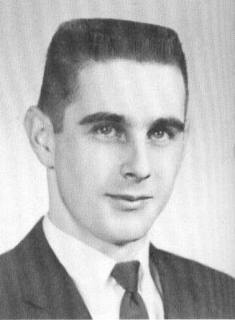

NAME: Ronald F Piroso

SPOUSE: Carol Ann (Wheeler)

ADDRESS: 72 W. Main Street
Warner, NH 03278

PHONE: (603) 456-3900

E-MAIL: ronp1943@tds.net

EMPLOYMENT: New England Telephone Company

CHILDREN:
Ronald Jr.
Suzanne
Deborah

* * * * * * * *
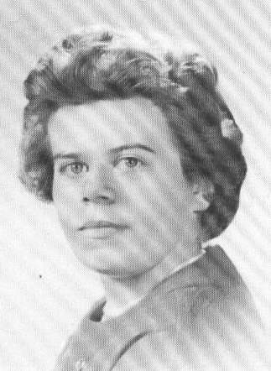

NAME: Lurlyne F (Pluff) Plummer

*** Unknown address

* * * * * * * *
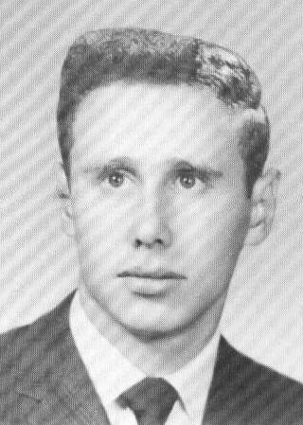
NAME: Lane A Plummer

SPOUSE: Diana

ADDRESS: 1185 Bergmann Drive
Stillwater, MN 55082

PHONE: (651) 342-0782

E-MAIL: lxplumm@comcast.net

EMPLOYMENT: Manager of a convenience store

CHILDREN:
Jean
Craig

1992 COMMENTS:
We can't make it to the reunion, but we will be in Concord visiting Charlie
Varnum the last of August.

* * * * * * * *
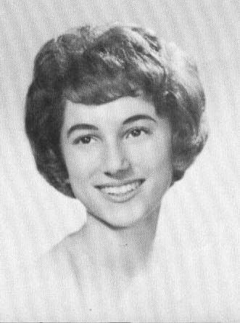

NAME: Sharon L (Popkin) Kimball

ADDRESS: PO Box 436
Concord, NH 03302

(Travels)

CELL: (603) 848-5137

* * * * * * * *
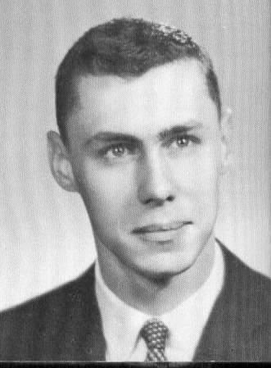
NAME: Bradley H Potter

SPOUSE: Joan L (Pingiaro)

Deceased:
xx/xx/1996 - Brain Tumor

EMPLOYMENT: Self Employed/Industry Analyst

CHILDREN:
Daniel

* * * * * * * *
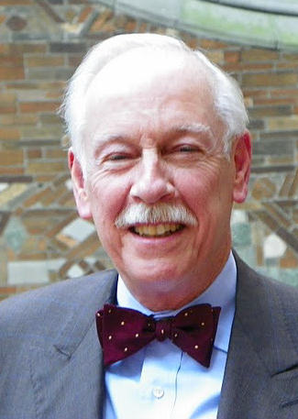NAME: Percy Preston, Jr.

ADDRESS: 311 West 91st Street
New York, NY 10024

PHONE: (212) 595-8979

E-MAIL: ppreston43@gmail.com

2012 COMMENTS:
In the fall of 1962, I enlisted in the US Army for three years and was stationed in Worms, Germany for half of that time. Returning to the
US in 1965, I enrolled in the University of Maryland, College Park.

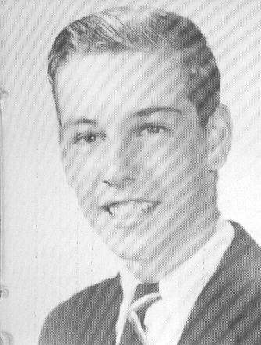
I graduated in 1969 with a B. A. in history, moved to New York City and began working in the trust department of Bankers Trust Company.

After a number of years, a career change took me in the direction of raising money for charities. Among other places, I worked at the New York Blood Center and Goodwill Industries of Greater New York.

Around ten years ago, I left my last full-time job to devote more time to writing, which I thoroughly enjoy. At the same time, the trustees of a small private foundation hired me to run the foundation’s office on a part-time basis.

My writing has produced a number of articles, including two in The Magazine
Antiques about architectural subjects. Later this year my history of the
House of the Redeemer, an Episcopal retreat house in New York that was
originally a private residence, should be published.

I also have the habit of getting involved with organizations and then finding myself in positions of some responsibility. St. Bartholomew’s Church, where I am a parishioner is one, and The University Club, where I chair the Library and Art Committee is another. In short, I have a range of activities (some more remunerative than others) to keep me busy.

On the personal front, I have a large number of relatives, especially my
sister, whom I see regularly. I also am fortunate to have a wide range of
friends, including our classmate Bob Rush, and five godchildren. As my one
attempt at matrimony ended badly, to my everlasting regret I have no children
of my own.

After my parents retired in 1972 and moved to New Jersey, I had less reason to visit Concord. These days, aside from driving through NH en route to Maine in the summer, I rarely visit the state. That said, I have fond memories of growing up in Concord, and send warm greetings to all members
of the class.

* * * * * * * *
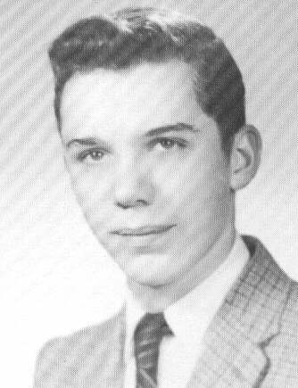

NAME: Kenneth G Price

ADDRESS: 151 Orchard Street
Forest City, NC 28043

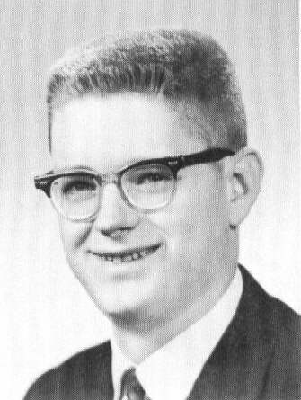
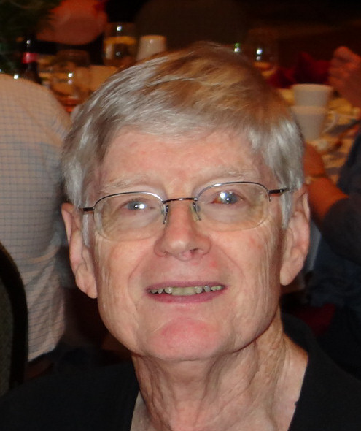
* * * * * * * *

NAME: Dr. Roderick (Rod) E Prior

SPOUSE-1: Meredith (Meredith passed away in 1998 from cancer)
SPOUSE-2: Holly (Price) (I married Holly Price in 2001)

ADDRESS: 243 High Street
Farmington, ME 04938

PHONE: (207) 778-9833

CHILDREN: E-MAIL: rprior04938@myfairpoint.net
Alison (1984)
Christopher (1988) EMPLOYMENT: Medical Director for MaineCare,
Maine's Medicaid program.
2012 COMMENTS:
Well, after CHS I spent 6 years in Hanover, graduating from Dartmouth College with a degree in math, and from Dartmouth Medical School for the first 2 years of med school. I then transferred to Harvard Medical School and graduated in 1970. After training at the University of Pennsylvania in Philadelphia, the National Institutes of Heath in Bethesda MD, and the Mass. General Hospital in Boston, I moved to Farmington, ME where I’ve lived ever since.

I married in 1971. My first wife, Meredith, died of cancer in 1998. I
remarried in 2001 and am happily married to Holly Price, a Chicagoan who
came to Farmington in the early 70’s and retired after a long teaching
career. I have 2 adult children, Alison age 28 and Chris age 23. Both
are still searching for their way in adult life.

I practiced internal medicine, occupational medicine, and hospital medicine
in Farmington for many years and ultimately worked as the medical director
for Farmington’s hospital for 15 years. I was also the medical director for
Maine’s Medicaid program for 4 years before retiring in 2011. I also have a
lifelong interest in computer technology and the use of information technology in healthcare. I still sit on two not-for-profit health IT corporate boards.

I’ve continued to play the clarinet (for over 60 years now) and have played
in a local university/community orchestra in Farmington for over 30 years.
Paul Giles and CHS ‘60 alumnus and clarinet player Annette Lawrence Backus
also lives in Farmington. We figured out each other’s history playing
clarinet together here a few years ago. I also like to cook and woodwork,
although I cut a finger off some years ago with a wood splitter!

Holly and I are traveling some in retirement and like to spend a few weeks
in Florida each March. I’m looking forward to seeing old friends this summer.

2009 COMMENTS:
Meredith died in 1998 after a very long battle with cancer. I single-
parented my kids for a few years and then remarried. Holly is from Chicago,
although she's lived in Farmington longer than my 33 years. She retired
after a teaching career 4 years ago and now concentrates on family, friends,
and community volunteering. I left my position as Medical Director at Franklin Memorial Hospital in 2007 and assumed the position as Medical
Director for MaineCare, Maine's Medicaid program. I'm now in the middle of
the dual challenges of preparing for healthcare reform and dealing with a
half-billion dollar budget shortage. Life remains full.

1992 COMMENTS:
Life is very full. Meredith and I adopted two children at the ripe age
of 40 and 44; our house is full of toys, dirty clothes, friends, sibling
rivalry, and all the other detritus of young children. And this at a time
when most of our friends are going to their kids' weddings.

I closed my internal medicine practice a few months ago to assume the
challenge of being Franklin Memorial's first medical director. The hospital
and I are together trying to figure out what a medical director should be
doing. Sorry to miss the reunion, but will be thinking of you.

* * * * * * * *
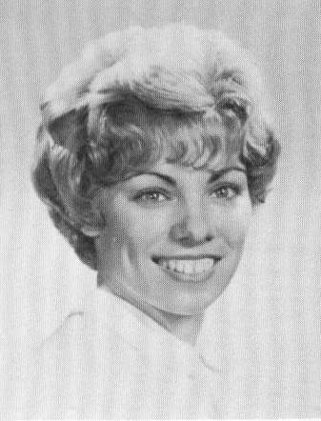
NAME: Nancy L (Provost)
Belanger

ADDRESS: PO Box 162
Nottingham, NH 03290

PHONE: (603) 679-1122

EMPLOYMENT: Carrier Family Jewelers
(Sales 23 years)

CHILDREN: COMMENTS:
Kevin --------- Still single
Denise --------- Married and living in Florida
GRANDCHILDREN:
Bryan
Kevin

1992 COMMENTS:
Looking forward to seeing everyone at the 30th Reunion. The last 2 reunions
were great! I am still talkative as ever and really love a good party. As
you will see on July l8th. Drink & Party Away!

* * * * * * * *
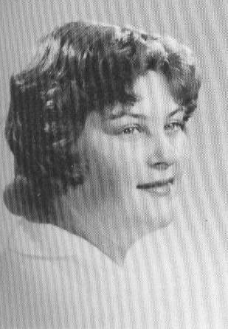
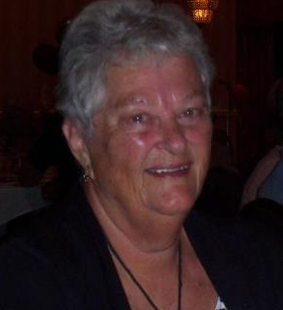

NAME: Nancy L (Putnam) Torrey

SPOUSE: Reginald Torrey

ADDRESS: 12315 SR 674 Lot #9
Lithia, FL 33547

PHONE: (813) 642-9210
CELL: (813) 748-3484

E-MAIL: nancyltorrey@earthlink.com
(uses SPAM blocker)

EMPLOYMENT: NH Hospital

CHILDREN: Reginald, Jr., Melissa

2012 COMMENTS:
After high school I went to work for the US Dept. of The Navy in Washington,
DC. My fiancé, Reg, came to visit me in April of 63 where we were married.

I worked out my two weeks’ notice and moved back to Laconia, NH where we lived
for 40 years. I worked for the Credit Bureau until my son; Reginald, Jr. was
born 1965. I stayed home for two years until my daughter, Melissa, was born
in Nov 1967. I went back to work in Jan. of 1968 until Aug. 1975, went to work
for the State of NH until retiring in June of 2004 as an Administrative Supervisor.

During those years we enjoyed camping, snowmobiling, vacations, cruising as a family until my daughter married and moved to Maine with her husband. My son stayed single until 2007 and married a Peruvian girl who has given birth to my
only grandchild, a granddaughter Mikaela, which I flew to NH and witnessed her birth. What a great experience! She was due on my birthday, but came three days later. Reg and I sold our house in NH and moved to Lithia, FL into a brand new double wide Palm Harbor Home. I stayed retired for one year, then went back to work part time for Big Jim II Self Storage as a manager and am still there.
Reg’s health was declining and after many adiation treatments, died of prostate cancer in March, 2010. We had been married 47 years.

I usually fly to NH every August for three weeks to be with my son and daughter, but this year I’m driving my motor home up with my brother sharing expenses.
I’m looking forward to seeing my classmates.


* * * * * * * *

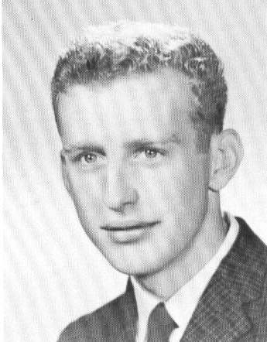
NAME: Edward C Rabbitt

SPOUSE: Anne

ADDRESS: 2704 Shriver Drive
Fort Myers, FL 33901

PHONE: (239) 362-3658

E-MAIL: arabbitt@yahoo.com

EMPLOYMENT: NH Peterbilt, owner
(Retired)
CHILDREN:
Donna
Pam
Mark
Kayla

* * * * * * * *
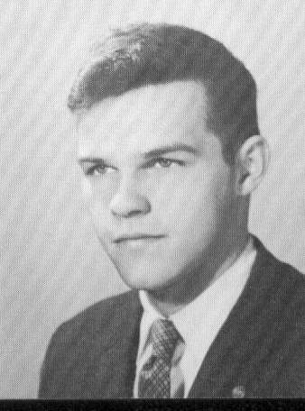

NAME: Charles R Rancour

Deceased:
04/12/1998 – Heart Attack

* * * * * * * *
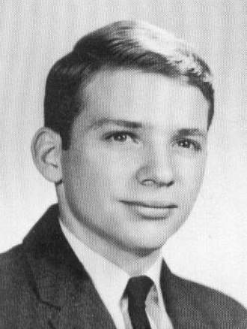

NAME: Roger O Randlett

ADDRESS: 633 SW Andras Circle
Port Saint Lucie, FL 34986

PHONE: (772) 878-9005

* * * * * * * *
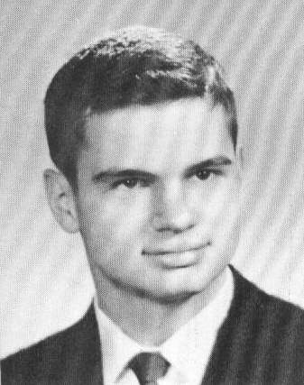

NAME: Francis Repas

ADDRESS: 1 5th Ave, Apt 15D
New York, NY 10003-4312

PHONE: (212) 995-8233
(718) 677-0955

* * * * * * * *
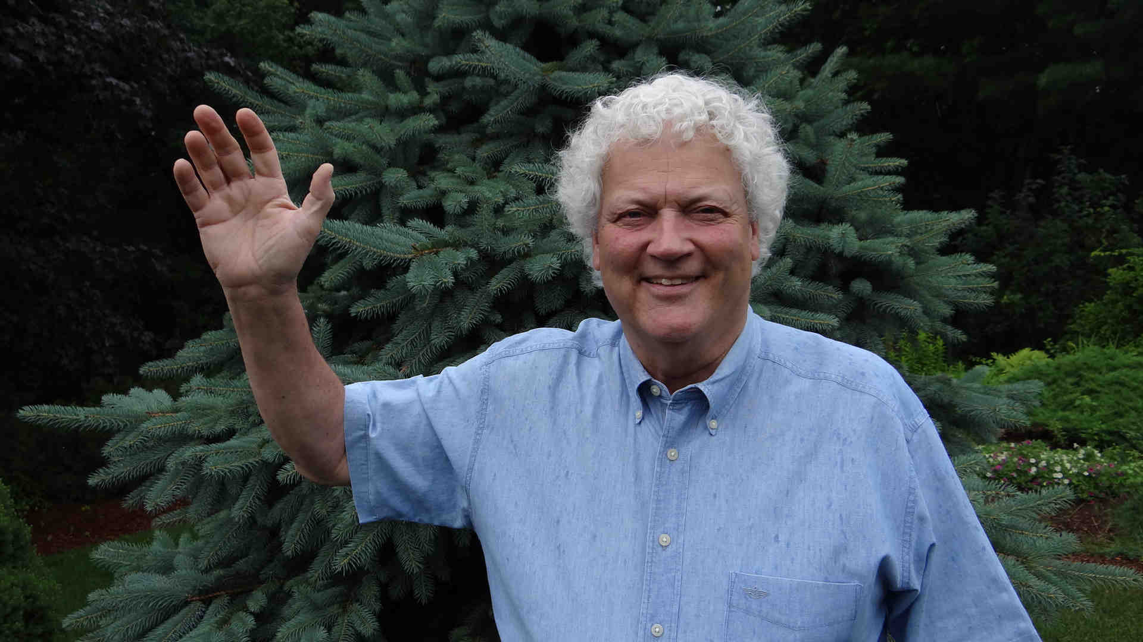

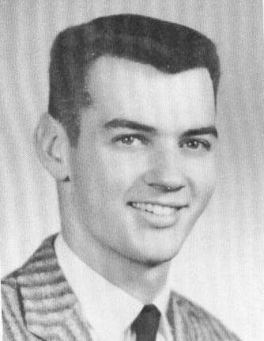
06/2012
NAME: Douglas G Richards

SPOUSE: Lisa (Ferriero)

ADDRESS: 4 Clough Road
Bow, NH 03304

PHONE: (603) 225-9062

E-MAIL: qualitypostcards@comcast.net

EMPLOYMENT: Retired from NH Bureau of
Elderly & Adult Services
in 2004 after 35 years as
a State-wide Consultant and Supervisor of Adult Protective & In-Home Care
Services.

I presently buy and sell antique & historic postcards and related ephemera. I am also moving into painting and the visual arts with an eye toward once again displaying and selling my pieces at shows and through galleries. Hey............know anything for sure these days? Or even 50 years ago.
One just thinks it to be the case.

CHILDREN:
Nathan (1978)
Laura (1992)

2012 COMMENTS:
My son, Nathan Douglas, is a PhD Aerospace Mechanical Engineer living in
Charlottesville, VA. Just so he gets it right, he also has his pilot's
license so that he knows what the pilots are talking about! I myself
chickened out of calculus so I cannot take any credit for that. But I
do take credit for his terrific sense of humor.

My 21 year old daughter, Laura Elisabeth, is also living in Charlottesville, VA. where she is studying art and psycholgy with an interest in art therapy. She presently volunteers in an art therapy program focusing on adults with mild to moderate cognitive impairment due to the new “Scarlet A”, Alzheimer's
Disease. Human Services.....like Father, like Daughter I'd say.

My mother, Estelle, was well into her 90s when I asked her if she'd share
with Nathan and Laura any “secrets” she could on her contentment and
longevity. She responded somewhat as follows and I paraphrase as best I
can. I pass her philosophy of life on to all of you as my wish for all
of you:
May you all (1) have things no matter how small to look
forward to each day, (2) build a bit of pleasure into
each day, and (3) be content with what you have and what
you have given back.

My mother died November 4th 2011 after a long life of 100 years, 1 week and
4 days. I'm thinking her philosophy helped her along the way.

Age 67/68 is not the end of life, but you certainly can see it from here. That's why I'm waving. My wife Lisa and I will be in England visiting with the Queen Mum during Reunion Weekend so I'll not be attending Reunion 50.

See you later.....or not.

* * * * * * * *
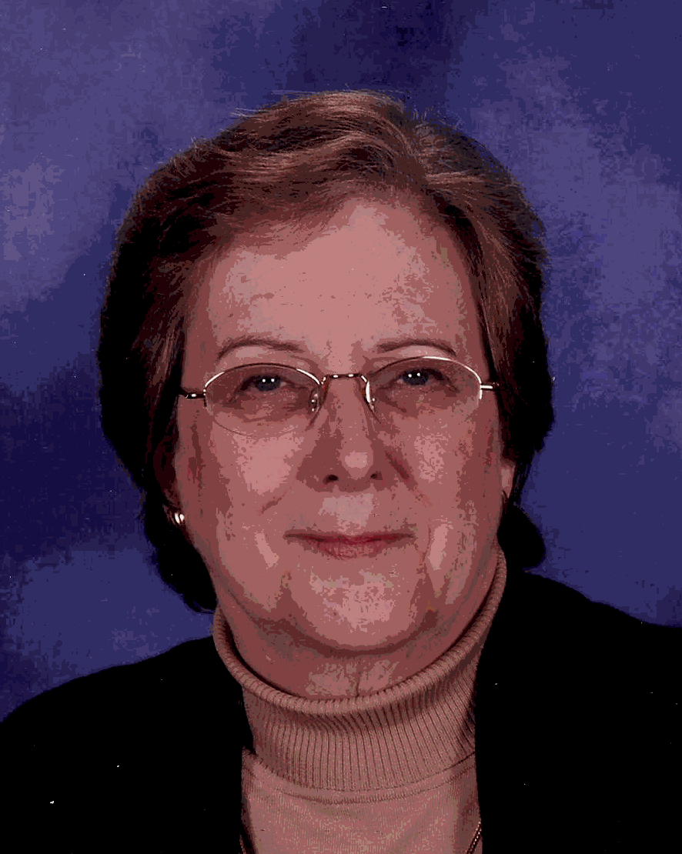
NAME: Judith E (Richmond)
Walters

ADDRESS: 3615 Littledale Road
Kensington, MD 20895

PHONE: (301) 946-0891

E-MAIL: waltersj@ninds.nih.gov

2012 COMMENTS:
I have read with interest and found reassuring
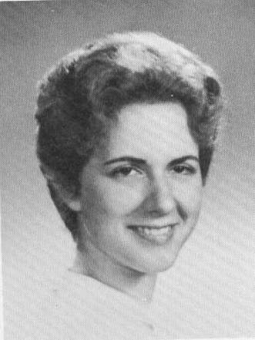
the many reports in this booklet of my classmates’ happy and fulfilling retirements! I have not yet taken the plunge, but for a
number of years now, I’ve been saying, “in just a few more years”. Meanwhile, I continue to really enjoy the opportunity to do research at the National Institutes of Health (NIH) in
Bethesda, MD, where I lead a small group of researchers studying how the motor centers in the brain are affected by Parkinson’s disease. Our goal is to understand what goes wrong in these brain areas to produce the motor symptoms associated with Parkinson’s and other motor disorders, and to try to develop better therapies to relieve these symptoms. I’ve
been working at the NIH since getting my PhD
in neuropharmacology in 1973.

Other highlights of life since graduation: I have 3 sons, now 27 – 35 yrs
old, who have brought me great pleasure and broadened my horizons. My ex-
husband and I have a very nice co-parenting relationship and I have had a
dear significant other/partner for 20 yrs, Tom Long, who is a professor at
Catholic University teaching in the Education dept.

My oldest son Jamie is currently doing a post-doc at Stanford Univ., studying
molecular biology and evolution, with a wife who is a filmmaker and college
teacher. Middle son, Greg, was a journalist in Russia for 5 years, now
living in Brooklyn NY, working part time for Credit Suisse bank, writing
music and touring with his band, Tiny Victories. Doug, the youngest, also
spent time after college touring with his band, Red Wire Black Wire, has a
couple albums out and is currently doing full time music composition. No –
I am not particularly musical myself and take no credit for my sons’ musical
accomplishments, but I did love playing the piccolo in the CHS marching band!

I’m looking forward to revisiting those happy memories and reconnecting with
classmates at our 50th reunion!

* * * * * * * *
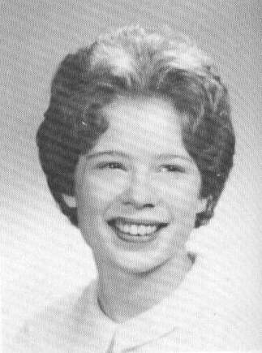

NAME: Rosemary G (Rideout)
Meding

ADDRESS: 33131 Serene Drive
Punta Gorda, FL 33982

PHONE: (941) 575-9952

E-MAIL: Rosemary.Meding@mygait.com

* * * * * * * *
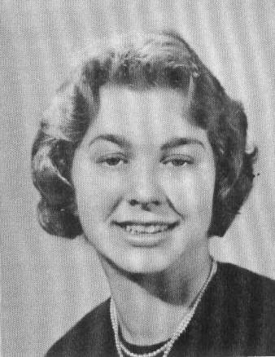

NAME: Patricia A (Riel) Coulter

Deceased:
04/xx/1998 - xxxxxxxxxx

* * * * * * * *
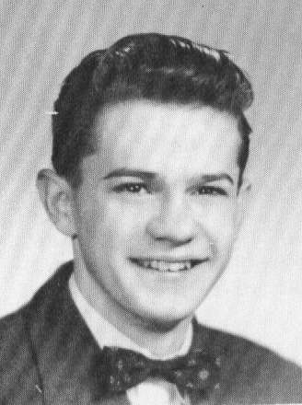

NAME: Richard L Roach

ADDRESS: 65 School Street
Manchester, CT 06040

* * * * * * * *
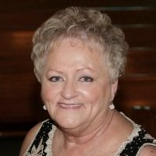
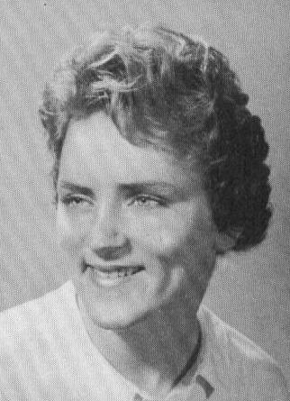
AME: Donna A (Robbins) Johnson

SPOUSE: Earl

ADDRESS: 200 Clift Farm Road
Falmouth, VA 22405

PHONE: (540) 373-9252

E-MAIL: Chatabox77@aol.com

EMPLOYMENT: Certified Municipal Town Clerk
for the Town of Dumfries, VA
(Retired 2010)

CHILDREN:
Corey (1974)
Kelley (1976)

2012 COMMENTS:
I have never attended one of our class reunions, but I am certainly looking
forward to attending the 50th and seeing everyone there.

* * * * * * * *
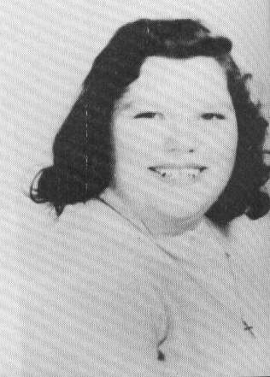
NAME: Laura (Robbins) Hildreth

Deceased:
03/18/2006 - xxxxxxxxxx

CHILDREN:
Robert

GRANDCHILDREN:
Haley (2001)

* * * * * * * *
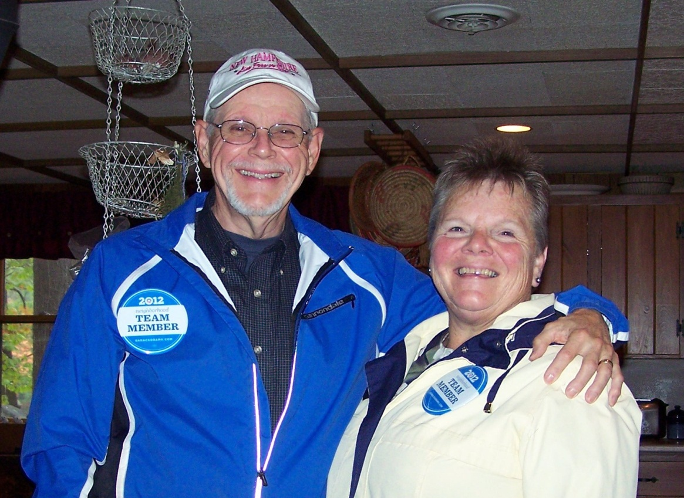

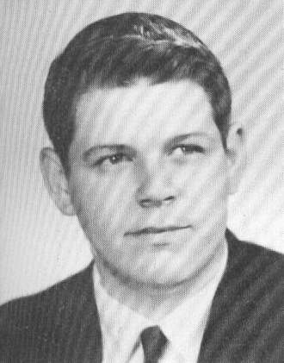
NAME: Dr. Glen E Rodgers

SPOUSE: Kathleen "Kitty" (Trumbull)
(Class of '64)

ADDRESS: PO Box 7075
Loudon, NH 03307

PHONE: (603) 227-9090

E-MAIL: glen.rodgers@allegheny.edu
kittyrodgers@hotmail.com

EMPLOYMENT: Professor emeritus of Chemistry,
Allegheny College (retired)
CHILDREN: COMMENTS:
Jennifer (1971) Vocal Teacher, Choral Conductor, Cabaret Singer,
Ashburn, VA
Rev. Dr. Emily (1974) Presbyterian Minister, Toronto, ON
Dr. Rebecca (1979) Palliative Care Physician, Chicago, IL

2012 COMMENTS:
In 2005, we retired and moved back to the Concord area.

I remember well the teachers at CHS that still make a difference in my life:

Mr. Alger Bourn, chemistry. He was so important that I have dedicated
all three editions of my inorganic chemistry textbook to him. The last
dedication in the 2012 3rd edition read: “Dedicated to Alger S. Bourn,
my high school chemistry teacher who ignited a continuing intellectual
passion”.

Miss Alma Sargent, mathematics. She gave me the confidence to believe
that I could go as far in mathematics as I needed and/or wanted to.

Miss Muriel Kendrick, English. She somehow browbeat into me the basics
of grammar and sentence structure. When I arrived at Tufts University,
it became apparent to me that she had taught me how to write well.
It’s a skill that I have valued all my life.

Career Highlights:
Bachelor of Science in Chemistry, Tufts University, 1966 Ph.D. in Chemistry,
Cornell University, 1971

Professor of Chemistry for 35 years (5 years at Muskingum College in New
Concord, OH and 30 years at Allegheny); winner of several teaching awards
including the Julian Ross Award, for “singular accomplishments and contri-
butions through excellence in teaching, Allegheny College, Meadville, PA”

Taught a number of interdisciplinary courses with colleagues in Education,
History, English, Philosophy, Geology, and Economics.

Author of Descriptive Inorganic, Coordination, and Solid-State Chemistry,
3rd Edition, Brooks/Cole, Cengage Learning 2012. Various editions have been
available domestically and internationally, including as Spanish and Korean
translations.

Leader of two Allegheny College Scientific/Historical Travel Seminars to
Europe. Present writing project: “Traveling with a Scientist, The History
of the Atom on the Road in Europe”.

Kitty and I have been married almost 46 years and have three daughters and
two grandchildren: Rachel, 16 months old and Rory, 2.5 years old.

I have made the transition from playing trumpet to singing tenor and have
enjoyed it for many years. We have sung with several choral groups in the
Concord area.

After growing up as a Baptist (United Baptist Church in Concord) and being
an American Baptist Scholar, we raised our children as Presbyterians. Now
we are members of the Canterbury United Community Church and love it there.

2002 COMMENTS:
We have lived in Meadville for 27 years but now spend our summers at Hot
Hole Pond in Loudon, NH.

1992 COMMENTS:
We have lived in Meadville for 17 years but manage to get back to Concord
at least once a year to see family and of course, get to Fenway Park.

* * * * * * * *

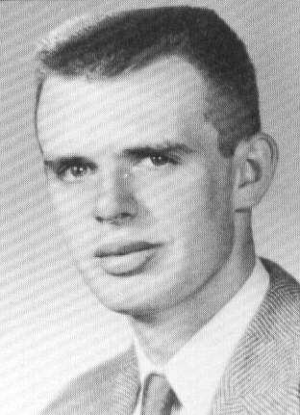

NAME: Clayton W Rollins

Deceased:
05/xx/1974 - Cancer

* * * * * * * *

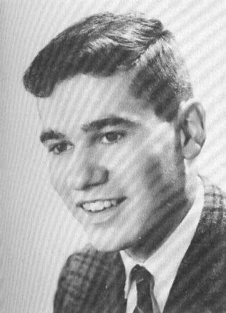
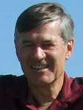

NAME: Dr. Richard D Rowell

ADDRESS: 3005 Stewart Campbell PT
Spring Hill, TN 371740-8524

PHONE: (615) 614-1365

E-MAIL: rowell@auxmail.iup.edu

* * * * * * * *

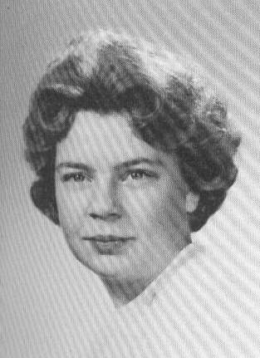

NAME: Nancy E (Rowse) Stackpole

ADDRESS: 4 Jackson Street
Concord, NH 03301

PHONE: (603) 224-4416

EMPLOYMENT: Ames Department Store

* * * * * * * *

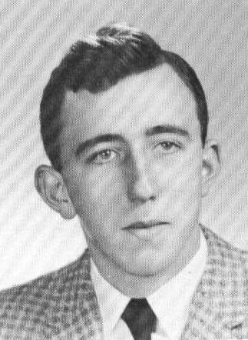

NAME: Frank G Roy

ADDRESS: 26 Allison Street
Concord, NH 03301

PHONE: (603) 482-3406

* * * * * * * *
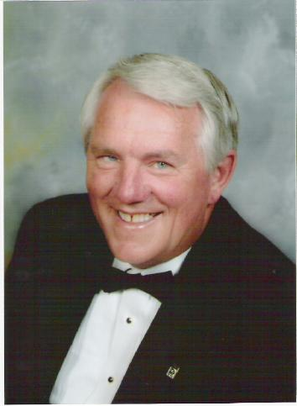
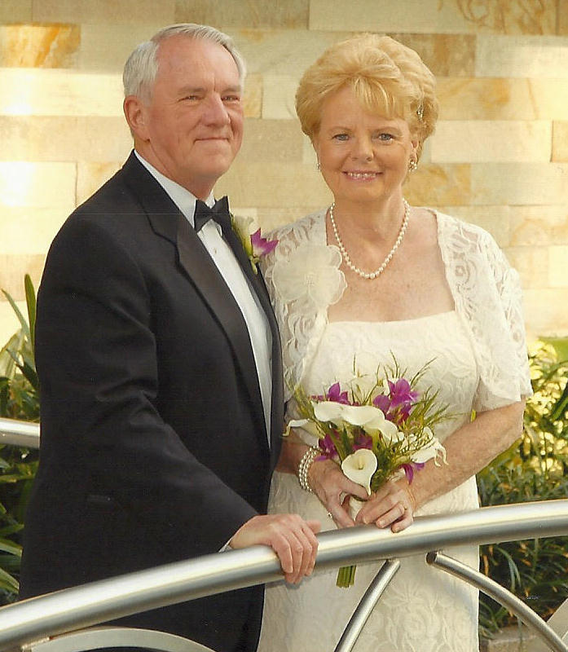

2005 2012 – 20 year wedding vow renewal

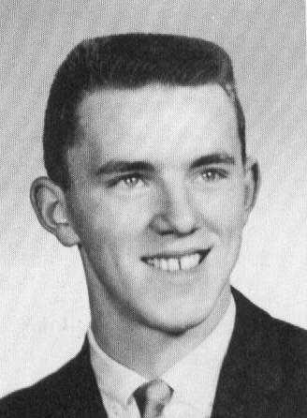
NAME: Michael R Royce

SPOUSE: Linda E (Miller)
(Manchester Memorial 1963)

ADDRESS: 77 Auburn Street
Concord, NH 03301-3047

PHONE: (603) 224-3805

E-MAIL: MRR@RoyceFamily.com

WEB PAGE: www.RoyceFamily.com

EMPLOYMENT: Computer Software Developer

CHILDREN: COMMENTS:
Ann (1964) Doing brain research at UCLA (tele-commuting)
GRANDCHILDREN:
Daniel (1984)
Nicole (1985)
Courtney (1991)

Stefanie (1967) Works at Globe in Pittsfield

Deborah (1971) Director of 2 departments,
(Linda's daughter) Cardiac Telemetry Care and Pulmonary Concord Hospital
GRANDCHILDREN:
Molly & Lauren (2001) Very much into school &
(identical twins) all sport activities.

2012 COMMENTS:
Another 5 years have passed.

WOW, 50 years, what a BIG number !!!

My wife, Linda, and I enjoy cruising after our honeymoon cruise in 1992.
Since then, we have been on 13 cruises (Hawaii, Caribbean, Panama Cannel,
Mediterranean, etc.). We had our 20 year wedding vows renewed on our March
2012 cruise on the largest cruise ship in the industry (Royal Caribbean
Allure) to the eastern & western Caribbean. We have 3 more planned for fall
of 2012, spring & fall of 2013.

Our house (that I designed and built in 1976) has not sold in over 5 years, SO, we have decided to stay and completely renovate it to our current liking.

I have been maintaining our reunion class records for over 16 years.
Unfortunately, Concord High School has not kept the alumni database (Bill
Haubrich, Jr. created with Will Brunkhorst) up to date. I have met with
administration with no satisfactory results (it is what it is).

Anyway, you may want to check your family information in all classes:
http://fm1.csd.k12.nh.us/fmi/iwp/cgi?-db=alumnichs&-loadframes
“Guest Account” <Login>
enter "whitepark" as the password
enter parameters as need

2007 COMMENTS:
Another 5 years have passed !!!

We are well at this end. We are preparing for retirement (or as much as
I expect to retire - I always expect to be busy doing something). We have
sold our classic 1963 Rolls-Royce Silver Cloud III, had a few yard sales,
our house is for sale so that we can move to a condo. We like cruising but
owning a house is harder to leave for very long.

2002 COMMENTS:
Hi, Classmates! 40 years have gone by.

From January 1963 to August 1974, I worked at Banks Chevrolet & Cadallic,
starting as a lubman working my way up to shop foreman.

From August 1974 to February 1976, I moved with my family to Mesa, AZ where
I worked at a Chevrolet dealership and went to tech school to become a
computer programmer.

We did not like AZ living. After moving back to Concord, I built my current
house & became a software developer (computer programmer).

Donna Clark (class of 1961) and I divorced in 1981 after 18 years of
marriage. I was single for 10 years. I placed an ad in a dating magazine
with Linda being 1 of 40 responses. Linda & I have been married since 1992.

I started my programming career at Concord Group Insurance. After 3 years,
I worked 10 years for the Concord School District as IT Director and
programmer building many projects with Mike Garrett. Because of budget cuts,
I had to move on. I was a computer contractor in Boston a few years working
for companies such as Fidelity, Bank of Boston, SunLife of Canada, etc.

For many years I have wanted to work out of my home, developing computer
applications. As we get older, our time becomes more important. I can work
anywhere (FL, AZ, the islands, etc.). Computers are so much fun, I don't
think I will ever retire in the true sense of retirement. I am always busy
doing something.

Linda is a RN and works as a contract nurse on local assignments and at
Harris Hill Nursing Home in Concord. She takes care of her grandchildren
two days a week. Kevin's mother takes the twins the other two days saving
much money on day care.

Our families are doing well. Ann & Family live in Northridge, CA. Ann works
at UCLA doing brain research. Stefanie lives in Pembroke and works at the
Globe in Pittsfield. Deborah & Family live in Penacook. Deborah is a
clinical leader in the cardiac telemetry unit at Concord Hospital. Kevin is
a programmer.

It was a lot of fun working on our 40th class reunion. Being in computers,
naturally most of my work is in the record keeping area. Over the years, I
have been concerned about our class information. Six years ago Roger gave me
our class information that his secretaries have been maintaining over the
years and I have been updating it since. I put our data in MS-Access97
database and will share it with anyone interested.

This past June, my father, 80, came back from AZ to his 63rd (class of 1939)
CHS reunion and had a great time.
* * * * * * * *

NAME: Jonathan Ruggles

SPOUSE: Jackie

ADDRESS: 4 Rockingham Street
Concord, NH 03301

PHONE: (603) 224-9350
(603) 224-4782 Work

E-MAIL: jrrtelec@rtelec.com

EMPLOYMENT: Owner of R&T Electric est. 1972

* * * * * * * *
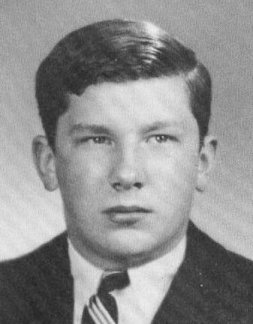
NAME: Robert Rush

SPOUSE: Andrea (Peters)

ADDRESS: 21 Judd's Bridge Road
New Milford, CT 06776

PHONE: (860) 354-2726

E-MAIL: brushphoto@sbcglobal.net

EMPLOYMENT: Retired photographer
Current member –
New Milford Planning Commission
Soccer Coordinator - NM Parks and Rec
President - NM Affordable Housing Commission
CHILDREN: COMMENTS:
MacAulay (1983) - Freshman, University of Vermont
Cayler (1985) - Senior, New Milford High School

2002 COMMENTS:
Proudly, both are honor students!

Mac just finished 1 year of volunteer service for AmeriCorp.

Cayler is a 3 sport varsity athlete and is a Premier League Soccer player.

1992 COMMENTS:
Involved in recycling. Volunteer Commissioner. Produced recycling radio
jingle, became a media darling. Network News, Wire Services, Feature Story
on Rush Family and Fresh Air Boy. Back to farming. Enjoying life, good
health and loving family. See you next time.

* * * * * * * *
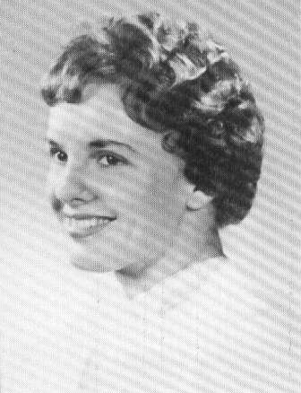
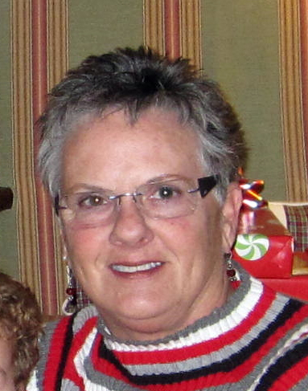

NAME: Agnes L (Russell) Gazaway

SPOUSE: David L Gazaway, Sr.

ADDRESS: 1148 Route 140
PO Box 33
Gilmanton, NH 03237

PHONE: (603) 872-2078
CELL: (603) 568-6845

E-MAIL: agnesgazaway@hotmail.com

EMPLOYMENT: Allied Insurance Agency (Retired)

CHILDREN: COMMENTS:
Audra (1969) and husband, Mark, live in Gilmanton with three
children, Ethan, Abigail, and Elliot. Mark and
Audra are both Campus Pastors for the Laconia
Campus of Grace Capital Church.

Brett (1971) and wife, Elizabeth, live in Denver, Co. with
two boys, Cameron and Chase. Brett is an underwater
photographer and editor for the National Park
Service branch of the U.S. Government.

2012 COMMENTS:
Worked 27 years as bookkeeper for family business, Allied Insurance Agency,
Inc. in Bow. Retired 7 years ago and love retirement. Spend time with
husband, David, family and grandchildren, who are the love of my life. Don't
know how I had time to do everything when I worked. We spend winters in
Melbourne Beach, FL and live in Gilmanton, NH the rest of the year.

2002 COMMENTS:
Live a pretty quiet life. Work part-time. Have a place in Melbourne, FL.
where we spend time in the winter.

Love being a grandmother. Spare time is spent with family and grandchildren.

